MARRYBROWN SALES AND PAYMENT ANALYTICS PLATFORM

YONG WERN JIE

UNIVERSITI TEKNOLOGI MALAYSIA

VALIDATION OF COLLABORATION

It is verified that this project is achieved through the collaboration between

MARRYBROWN SDN. BHD.
and
UNIVERSITI TEKNOLOGI MALAYSIA

Verified by (Industry): | Date:
Signature:
Name: Dr. Noor Irliana Binti Mohd Rahim
Affiliation: MARRYBROWN SDN. BHD.
Official stamp:

Verified by (University): | Date:
Signature:
Name: Dr. Noorfa Haszlinna binti Mustaffa
Affiliation: UNIVERSITI TEKNOLOGI MALAYSIA
Official stamp:

ABSTRACT
This project proposes the development of a company-owned Sales and Payment Analytics Platform to reduce operational risk associated with dependence on a third-party cloud point-of-sale (POS) reporting portal in a large-scale food and beverage (F&B) enterprise. In the current setting, Finance and Operations stakeholders rely on vendor-managed exports and portal interfaces for routine reconciliation and month-end closing, which constrains ad hoc analysis, limits transparency into underlying transactions, and can delay issue resolution when vendor services are degraded or unavailable. The proposed platform adopts a redundancy architecture in which key transactional tables are replicated 1:1 into a Microsoft SQL Server environment, preserving raw data fidelity and traceability, while an ELT workflow refreshes replicated data within defined boundaries to support safe reruns and late adjustments. Report calculations are reconstructed at a semantic layer exposed through a FastAPI service, enabling schema-on-read transformations that keep business rules versioned and auditable and decouple the reporting portal from database implementation details. The project adopts an iterative and incremental development approach in which report requirements are inferred from vendor exports and stakeholder feedback, implemented through a Python-based ELT workflow using SQLAlchemy and pyodbc, and delivered through FastAPI and a React-based reporting portal. The project targets fifteen high-priority sales and payment reports and evaluates report-level parity through iterative reverse engineering and reconciliation-driven validation against vendor exports for matched parameters (e.g., outlet and date range), complemented by cross-report consistency checks to support fitness-for-use in financial reporting. The expected outcome is an independently operated reporting environment that improves accessibility for Finance and Operations, supports continuity of reporting during vendor disruptions, and provides a defensible basis for ongoing report maintenance through documented validation evidence.

ABSTRAK
Projek ini mencadangkan pembangunan Platform Analitik Jualan dan Pembayaran milik organisasi bagi mengurangkan risiko operasi yang berpunca daripada kebergantungan terhadap portal pelaporan pihak ketiga berasaskan awan bagi sistem titik jualan (POS) dalam sebuah organisasi makanan dan minuman (F&B) berskala besar. Dalam keadaan semasa, pihak Kewangan dan Operasi bergantung kepada eksport serta antara muka portal yang diurus vendor untuk kerja-kerja semakan dan pendamaian rutin, khususnya semasa penutupan hujung bulan; keadaan ini mengehadkan analisis ad hoc, mengurangkan ketelusan terhadap transaksi asas, dan berpotensi melambatkan penyelesaian isu apabila perkhidmatan vendor mengalami kemerosotan prestasi atau gangguan. Platform yang dicadangkan menggunakan seni bina redundansi yang membolehkan jadual transaksi utama direplikasi secara 1:1 ke persekitaran Microsoft SQL Server milik organisasi bagi mengekalkan kesetiaan data mentah dan kebolehkesanan, manakala aliran kerja ELT menyegar semula data replika dalam sempadan yang ditentukan untuk menyokong ulangan semula yang selamat serta pelarasan lewat. Logik pengiraan laporan dibina semula pada lapisan semantik yang didedahkan melalui perkhidmatan FastAPI, sekali gus membolehkan transformasi schema-on-read supaya peraturan perniagaan kekal dikawal dari segi versi dan boleh diaudit serta memisahkan portal pelaporan daripada perincian pelaksanaan pangkalan data. Projek ini mengguna pakai pendekatan pembangunan iteratif dan berinkremen, dengan keperluan laporan dikenal pasti daripada eksport vendor dan maklum balas pihak berkepentingan, dilaksanakan melalui aliran kerja ELT berasaskan Python yang menggunakan SQLAlchemy dan pyodbc, serta disampaikan melalui FastAPI dan portal pelaporan berasaskan React. Projek ini mensasarkan lima belas laporan jualan dan pembayaran berkeutamaan tinggi, serta menilai kesepadanan pada peringkat laporan melalui kejuruteraan songsang secara iteratif dan pengesahan berasaskan pendamaian terhadap eksport vendor bagi parameter yang sepadan, seperti cawangan dan julat tarikh, di samping semakan konsistensi antara laporan untuk menyokong kesesuaian penggunaan dalam pelaporan kewangan. Hasil yang dijangkakan ialah persekitaran pelaporan yang dikendalikan secara bebas yang meningkatkan kebolehcapaian bagi pihak Kewangan dan Operasi, menyokong kesinambungan pelaporan semasa gangguan perkhidmatan vendor, dan menyediakan asas yang boleh dipertahankan bagi penyelenggaraan laporan melalui bukti pengesahan yang didokumenkan.

TABLE OF CONTENT
 | TITLE | PAGES

ABSTRACT II
ABSTRAK III
TABLE OF CONTENT IV
LIST OF TABLES VIII
LIST OF FIGURES X
Chapter 1 INTRODUCTION 1
1.1 Introduction 1
1.2 Problem Background 2
1.3 Problem Statement 3
1.4 Project Aim 3
1.5 Project Objectives 4
1.6 Project Scope 4
1.7 Project Importance 5
1.8 Report Organization 6
Chapter 2 LITERATURE REVIEW 7
2.1 Introduction 7
2.2 Fundamental Theory and Concepts 7
2.2.1 Sales and Payment Reporting in Vendor-Managed POS Environments 7
2.2.2 Data Warehousing and Replication-Based Analytical Stores 8
2.2.3 Data Integration Pipelines: ETL vs ELT and Idempotent Loads 9
2.2.4 Replication, Availability, and Consistency Considerations 9
2.2.5 Schema-on-Read, Database Design, Semantic Layers, and Service Interfaces 10
2.2.6 Reverse Engineering and Black-Box Validation of Legacy Reports 11
2.2.7 Data Quality and Reconciliation for Financial Reporting 11
2.2.8 Iterative Development Approaches for Evolving Requirements 12
2.3 Related Previous Researches/Systems and Comparative Discussion 12
2.4 Workflow and Interface Considerations for Operational Reporting Portals 14
2.5 Technology Used 16
2.6 Synthesis and Rationale Map 17
2.7 Synthesis and Rationale Map 18
Chapter 3 METHODOLOGY 19
3.1 Introduction 19
3.2 Methodology Choice and Justification 19
3.3 Phases within the Iterative and Incremental Development Methodology 20
3.3.1 Phase 1: Requirement Analysis (Document Analysis and Stakeholder Feedback) 22
3.3.2 Phase 2: System Design 23
3.3.3 Phase 3: Implementation 24
3.3.4 Phase 4: Testing & Validation (Parity and Reconciliation) 25
3.3.5 Phase 5: Deployment 26
3.3.6 Phase 6: Review & Feedback 26
3.4 Project Schedule (Gantt Plan for FYPi1 and FYPi2) 27
3.5 System Requirement Analysis: Hardware and Software 28
3.5.1 Hardware Requirements 29
3.5.2 Software Requirements 29
3.6 Summary 30
Chapter 4 ANALYSIS AND DESIGN 31
4.1 Introduction 31
4.2 System Analysis 31
4.2.1 Case Study Context (Continuity Reporting for Sales and Payments) 31
4.2.2 Stakeholders and Role-Based View 32
4.2.3 System Requirements Gathering Techniques 32
4.2.4 Use Case Diagram 33
4.2.5 User Requirement Outcomes 34
4.3 System Requirements 34
4.3.1 Functional Requirements (FR) 34
4.3.2 Non-Functional Requirements (NFR) 35
4.3.3 Constraints and Assumptions 35
4.4 Current System Analysis 36
4.5 System Design 36
4.5.1 System Architecture 36
4.5.2 Component Explanations 37
4.5.3 Data Engineering and API Design 38
4.5.3.1 Data Sources and Replication Boundary 38
4.5.3.2 Refresh Cadence and Idempotent Load Pattern 39
4.5.3.3 Error Handling, Logging, and Monitoring 40
4.5.3.4 API Endpoint Pattern and Semantic Layer Responsibilities 41
4.5.3.5 Security Considerations 42
4.5.3.6 Report Logic Reconstruction Pattern and Representative Examples 42
4.5.4 Database Design 43
4.5.5 Business Rule Reconstruction for the Fifteen Targeted Reports 45
4.5.6 Interface Design 46
4.5.7 Summary 48
REFERENCES 49
Appendix A: Report Specifications 52
A.1 Specification Template (per report) 52
A.2 Target Report Index (15 reports) 53
A.3 Report Specifications (to be completed iteratively) 54
R01: Daily Sales Summary 54
R02: Payment Type (All Payment) 55
R03: Sales Return Report 56
R04: Sales Cancelled Report 57
R05: DELETED Items Report 58
R06: Sale Delivery (By Sales Type) Ex Tax Calculation 59
R07: MB Cash Voucher (with Barcode) Redemption Report 60
R08: MB Staff E-Voucher RM 20 & MB CASH VOUCHER RM10 (with Barcode) Redemption Report 61
R09: Product Mix Report 62
R10: Discount Remark Report 62
R11: Delivery-FoodPanda,Grabfood,ShopeeFood 63
R12: Foodpanda Sales 63
R13: Foodpanda Discount 64
R14: Mobile Ordering Sales 65
R15: Pickup & Declaration Report 65

LIST OF TABLES
Table 1.1: Current progress summary (as of Week 28 of the internship) 7
Table 2.1: Comparative discussion of vendor-managed reporting versus company-owned redundancy reporting 15
Table 2.2: Reporting portal workflow and interface considerations for the proposed platform 18
Table 2.3: Synthesis / rationale map linking proposed choices to literature 20
Table 3.1: Phase-level inputs, activities, and evidence artefacts (per report module) 24
Table 3.2: Project schedule and status summary (Weeks 1–28) 30
Table 3.3: Hardware requirements (high-level) 31
Table 3.4: Software requirements (high-level) 32
Table 4.1: Stakeholder groups and reporting needs (role-based view) 34
Table 4.2: Functional requirements for the proposed platform 37
Table 4.3: Non-functional requirements for the proposed platform 37
Table 4.4: Component responsibilities and design considerations 40
Table 4.5: Conceptual data dictionary (summary) 47
Table A.1: Report specification template fields 54
Table A.2: Target report index (15 reports) and status summary (Week 28) 56
Table A.3: Report specification fields for R01 (Daily Sales Summary) 57
Table A.4: Report specification fields for R02 (Payment Type (All Payment) 58
Table A.5: Report specification fields for R03 (Sales Return Report) 59
Table A.6: Report specification fields for R04 (Sales Cancelled Report) 60
Table A.7: Report specification fields for R05 (DELETED Items Report) 61
Table A.8: Report specification fields for R06 (Sale Delivery (By Sales Type) Ex Tax Calculation) 62
Table A.9: Report specification fields for R07 (MB Cash Voucher (with Barcode) Redemption Report) 63
Table A.10: Report specification fields for R08 (MB Staff E-Voucher RM 20 & MB CASH VOUCHER RM10 (with Barcode) Redemption Report) 64
Table A.11: Report specification fields for R09 (Product Mix Report) 64
Table A.12: Report specification fields for R10 (Discount Remark Report) 65
Table A.13: Report specification fields for R11 (Delivery-FoodPanda,Grabfood,ShopeeFood) 65
Table A.14: Report specification fields for R12 (Foodpanda Sales) 66
Table A.15: Report specification fields for R13 (Foodpanda Discount) 66
Table A.16: Report specification fields for R14 (Mobile Ordering Sales) 67
Table A.17: Report specification fields for R15 (Pickup & Declaration Report) 68

LIST OF FIGURES
Figure 1.1: Comparison of Current Vendor Dependency vs. Proposed Redundancy Architecture 5
Figure 3.1: Iterative Workflow for Analytics Platform Development 22
Figure 3.2: High-level system workflow (data replication to report delivery) 29
Figure 4.1: Use case diagram for the proposed Sales and Payment Analytics Platform (illustrative) 35
Figure 4.2: Current vendor-dependent reporting workflow (simplified) 38
Figure 4.3: Proposed logical architecture of the analytics platform 39
Figure 4.4: Proposed boundary-based refresh and report-serving sequence (illustrative) 42
Figure 4.5: Simplified conceptual data model for sales and payment reporting (illustrative) 46
Figure 4.6: Report list view prototype (illustrative) 48
Figure 4.7: Reporting view prototype (illustrative) 49
Figure 4.8: Portal navigation and report workflow (illustrative) 50

INTRODUCTION

Introduction
In contemporary retail operations, timely access to trusted transaction data is essential for operational oversight and informed decision-making. In practice, many organisations consolidate operational data into analytical repositories (e.g., data warehouses) to support reporting, governance, and performance monitoring (Inmon, 2005; Kimball & Ross, 2013). Large-scale food and beverage (F&B) enterprises such as Marrybrown generate high volumes of sales and payment transactions across multiple outlets, which increases the importance of reliable reporting and data accessibility.
In the current setting, the organisation relies on a third-party cloud point-of-sale (POS) vendor for both transaction processing and analytical reporting. Sales and payment information is primarily accessed through vendor-managed portal views and exported files, which are used by Finance and Operations stakeholders for daily review, reconciliation activities, and month-end closing. While this arrangement can reduce initial implementation effort, cloud computing guidance highlights that reliance on external service providers can introduce availability, control, and security considerations that must be actively managed (Badger et al., 2012; Jansen & Grance, 2011).
Accordingly, the existing sales and payment reporting environment is characterised by high transaction volume, dependence on vendor-managed access channels, and the need for timely, trusted outputs for operational and financial workflows. This context establishes the basis for examining the practical limitations of the current reporting arrangement, which are discussed in the following sections.

Problem Background
The organisation currently relies on a third-party POS service provider for operational data storage and reporting. This creates a single point of failure for critical Finance and Operations reporting activities: when the vendor's cloud services experience downtime or latency, internal stakeholders may be unable to access required transaction data and reports.
A practical constraint is limited internal visibility and control over the sales and payment datasets. Access is typically mediated through the vendor interface, which restricts flexible querying and reduces the organisation's ability to perform ad hoc investigations or rapid enhancements. When disruptions occur, incident resolution is dependent on vendor support processes, which may not align with internal operational timelines.
Internal observations further indicate that report generation may fail or become unavailable during month-end closing periods, when reporting load is typically higher. Even short periods of reporting unavailability during such critical windows can disrupt verification workflows and delay financial reconciliation activities, potentially affecting downstream audit preparation.
As illustrated in Figure 1.1, the current reporting arrangement provides a direct but vendor-dependent path from the external POS and reporting portal to Finance and Operations users, whereas the proposed redundancy architecture introduces an alternative reporting path through replication and ELT, a company-owned SQL Server replica, a semantic layer, and an internal reporting portal. This comparison highlights how the existing arrangement concentrates reporting access within vendor-managed services, while the proposed design shifts reporting delivery into components under organisational control.
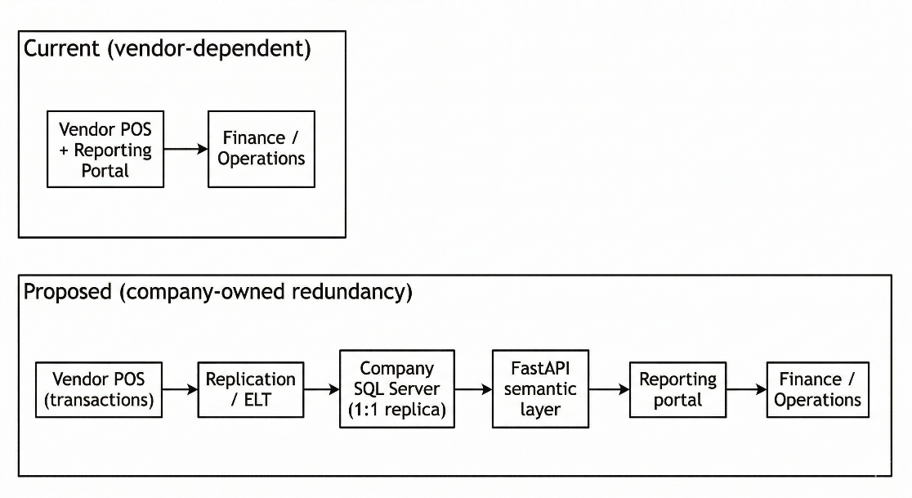
Figure 1.1: Comparison of Current Vendor Dependency vs. Proposed Redundancy Architecture

Problem Statement
Based on the organisational context described above, this project addresses four interrelated problems. First, reliance on a single third-party reporting portal creates a single point of failure for sales and payment reporting activities. Second, limited direct visibility into transactional datasets restricts ad hoc analysis and slows internal investigations. Third, vendor-dependent incident resolution may not meet operational timelines, particularly during critical reporting windows. Finally, report unavailability during month-end closing periods can disrupt reconciliation work and delay downstream audit preparation.

Project Aim
The aim of this project is to develop a resilient, company-owned Sales and Payment Analytics Platform that serves as a functional redundancy system for the external POS portal, enabling continued access to critical operational reports through a 1:1 database replication architecture.

Project Objectives
To achieve the stated aim, the following specific objectives have been defined:
- To define stakeholder requirements for continuity sales and payment reporting, including report-level acceptance criteria for parity validation.
- To design a company-owned 1:1 replicated transactional schema in Microsoft SQL Server that ensures data fidelity and traceability for the targeted reporting outputs.
- To reconstruct the business rules for fifteen targeted sales and payment reports within a semantic/API layer, ensuring report-level parity with vendor exports.
- To develop an interactive web-based reporting portal with operational usability, performance monitoring, baseline security controls, and recovery procedures.

Project Scope
This project covers the end-to-end development of a custom analytics platform, spanning data extraction, replication, report logic reconstruction, and user-facing reporting. The replication scope focuses on sales and payment datasets required to support the targeted reporting outputs.
The core development focus is the logic reconstruction of 15 critical sales and payment reports. The backend service is being developed using a Python-based API layer (FastAPI) to apply schema-on-read transformations and implement report logic in a controlled and auditable manner. The project applies reverse engineering and report-level parity validation to align reconstructed outputs with the vendor portal.
Although fifteen reports are defined as targeted outputs, implementation is scheduled incrementally: initial iterations prioritise a subset of high-impact operational reports for early reconstruction and parity validation, while the remaining reports are completed in subsequent iterations as described in Chapter 3.
System development includes a sales and payment analytics portal being developed using React to support Finance and Operations users in viewing and exporting required reports. The platform is designed as a read-only redundancy system and does not support write-back operations to the vendor POS system. Inventory and customer relationship management (CRM) analytics are excluded from the current scope and are reserved for future work.
Workstream | Status (Week 28) | Notes
Data warehouse and cloud environment | Deployed (development environment) | Deployed for iterative development and stakeholder review; production hardening remains ongoing.
Report APIs | 7 of 15 implemented and validated | Validation performed against vendor exports using parity and reconciliation checks.
Portal frontend | 4 reports implemented | Remaining report views will be implemented as additional APIs are completed.
Replication and ELT automation | Manual scripts available | Scheduling and automation are planned for later iterations.
Table 1.1: Current progress summary (as of Week 28 of the internship)

Project Importance
This project is significant because it addresses an operational vulnerability arising from dependence on a third-party reporting portal for critical sales and payment information. By establishing a company-owned replica and reporting layer, the organisation is expected to improve continuity of access to reports and reduce exposure to vendor-side service disruptions. From an information quality perspective, the project emphasises reconciliation and report-level parity checks to support the fitness-for-use of reproduced outputs for financial reporting (Wang & Strong, 1996).
In addition, this work provides a structured case study on designing a redundancy reporting platform using replication, ELT practices, and iterative validation. The resulting architecture can serve as a foundation for future analytical enhancements once the core sales and payment reporting requirements are stabilised.
The contribution of this project lies not only in delivering a continuity reporting platform, but also in demonstrating a practical, validation-driven approach for reconstructing vendor-dependent operational reports using replicated transactional datasets.

Report Organization
Chapter 1 introduces the project context, problem statement, aim, objectives, scope, importance, and the organisation of the report. Chapter 2 reviews relevant literature on vendor dependency risks, replication and ELT approaches, schema-on-read and semantic layers, data quality and reconciliation, and iterative development approaches. Chapter 3 presents the methodology for executing the project, including the parity validation strategy and the project schedule. Chapter 4 documents the analysis and design of the proposed system, including system analysis, requirements, current system analysis, and detailed design artefacts.

LITERATURE REVIEW

Introduction
This chapter reviews scholarly and standards-based literature that grounds the proposed Sales and Payment Analytics Platform as a company-owned reporting redundancy system for an externally managed point-of-sale (POS) reporting portal. The review is structured to support an evidence-based proposal: fundamental concepts are introduced first, then related work and comparative discussion are synthesised to justify the chosen architecture and validation approach, followed by a brief discussion of the technologies selected for implementation.

Fundamental Theory and Concepts

Sales and Payment Reporting in Vendor-Managed POS Environments
In vendor-managed POS environments, transaction processing and report access may be delivered through the same externally managed service boundary. From a cloud-computing perspective, this arrangement places operational reporting within a third-party availability, security, and change-management context rather than wholly under organisational control (Mell & Grance, 2011; Badger et al., 2012; Jansen & Grance, 2011). For sales and payment reporting, this matters because daily totals, payment breakdowns, and reconciliation outputs are often consumed through vendor-managed portal interfaces and exports rather than through an internally operated reporting stack.
The literature also highlights lock-in effects in cloud adoption, where switching providers or rebuilding capabilities can incur high technical and operational costs (Armbrust et al., 2010). These costs are amplified when report logic exists primarily in a vendor-managed portal and is not fully documented or reproducible by the organisation. Consequently, continuity-oriented initiatives commonly prioritise retaining organisational access to usable transaction data and establishing reporting capabilities that are less exposed to vendor-side service disruptions (Badger et al., 2012; Armbrust et al., 2010).

Data Warehousing and Replication-Based Analytical Stores
Data warehousing literature frames a data warehouse as an integrated repository designed to support reporting and analysis rather than operational transaction processing (Inmon, 2005; Kimball & Ross, 2013). For sales and payment analytics platforms, this repository forms the database foundation for storing duplicated transactional data in a form that remains queryable for reporting while preserving a clear relationship to operational records. Traditional designs frequently apply modelling and transformation choices (e.g., dimensional modelling) to optimise analytical queries, but such transformations can increase complexity and may obscure traceability to source records if governance is weak.
For reporting redundancy, an alternative design is a fidelity-first replicated analytical store that preserves the structure and content of source transactional tables. This approach prioritises traceability and simplifies reconciliation by reducing ambiguity about how report outputs relate to replicated source records. In practice, the choice between an optimised dimensional model and a replicated fidelity-first store depends on the primary objective: performance optimisation versus assured traceability and parity with externally generated reports (Inmon, 2005; Kimball & Ross, 2013).

Data Integration Pipelines: ETL vs ELT and Idempotent Loads
Data integration pipelines are commonly described using ETL (extract-transform-load), where data is transformed prior to loading into the target repository (Kimball & Caserta, 2004). In sales and payment analytics platforms, these pipelines form the process layer that moves vendor-originated data into the organisation-controlled reporting environment. Contemporary data platform practices also adopt ELT patterns, in which raw data is loaded first and transformations are applied in the target environment. This aligns with schema-on-read approaches that preserve raw data while enabling flexible downstream transformations (Azzabi et al., 2024).
For operational reliability, pipeline design must consider rerun safety and operational recovery. Idempotent loading patterns reduce the risk of duplicate records and support repeatable refresh cycles when failures occur or when late data corrections are detected. In practice, idempotency is achieved through controlled load boundaries (e.g., date-range refresh) and deterministic processing rules that yield the same replicated state for the same boundary.

Replication, Availability, and Consistency Considerations
Replication is used to improve availability and support resilience by maintaining copies of data across systems. In distributed and replicated systems, trade-offs between consistency, availability, and operational complexity are central design considerations (Kleppmann, 2017). For reporting redundancy, strict real-time consistency is typically not required; instead, the practical objective is timely access to sufficiently recent and internally consistent data, supported by a refresh process and validation evidence that stakeholders can trust during reporting-intensive periods.
Accordingly, replication design in reporting contexts is commonly paired with operational controls (e.g., rerun capability, logging, and post-load checks) to manage failure recovery and to provide confidence in the replicated state. These controls support both day-to-day reporting and the investigative workflows that arise when discrepancies are detected.

Schema-on-Read, Database Design, Semantic Layers, and Service Interfaces
Schema-on-read practices emphasise preserving raw or lightly transformed datasets and applying transformations at consumption time, which supports iterative refinement of business logic while maintaining traceability (Azzabi et al., 2024). For reporting platforms that duplicate operational sales and payment data, this principle supports database designs in which replicated tables remain close to source structure, while report-specific calculations are handled separately for auditability and change control (Inmon, 2005; Kimball & Ross, 2013).
Data repository design and semantic design are therefore related but distinct concerns. Data warehousing literature differentiates between storage structures used to retain and organise data and presentation or consumption structures used to deliver consistent analytical views (Inmon, 2005; Kimball & Ross, 2013). In this project context, reconstructed report logic is treated as semantic-layer logic: duplicated transactional data are retained for traceability, while business rules, derived fields, and report-specific aggregation behaviour are centralised above the database layer to reduce metric drift and simplify maintenance.
For service delivery, REST is a widely cited architectural style for network-based systems, emphasising stateless communication, uniform interfaces, and resource-oriented design (Fielding, 2000). A RESTful API therefore provides a standard mechanism to deliver report outputs to a portal while decoupling report consumption from underlying database implementation details and keeping business-rule changes versioned and auditable at the service layer.

Reverse Engineering and Black-Box Validation of Legacy Reports
When vendor report logic is proprietary and not fully documented, reverse engineering and design recovery provide a structured lens for inferring behaviour from observable artefacts (Chikofsky & Cross, 1990). In such settings, black-box testing methods support parity validation by comparing system outputs against vendor exports under identical parameters (Myers et al., 2011). For reporting platforms, this process extends beyond matching totals; it also requires validating calculation rules and edge-case handling (e.g., returns, voids, split tenders, and rounding behaviour) to reduce operational reconciliation risk.

Data Quality and Reconciliation for Financial Reporting
Data quality is commonly framed as fitness for use, where suitability depends on the consumer’s needs and the use context (Wang & Strong, 1996). Standards and reference models describe core quality characteristics such as accuracy, completeness, consistency, and timeliness (International Organization for Standardization, 2008). In sales and payment reporting, these characteristics are directly relevant because stakeholders require totals, breakdowns, and reconciliation outputs that are dependable for decision-making and audit preparation.
Data quality management literature discusses practical techniques for assessing and improving data quality, including profiling and validation rules (Batini & Scannapieco, 2006). In replicated reporting contexts, these techniques are operationalised through reconciliation checks (e.g., cross-report consistency of totals) and repeatable parity comparisons against vendor exports for agreed validation windows.

Iterative Development Approaches for Evolving Requirements
Iterative development approaches emphasise incremental delivery and feedback-driven refinement (Beck et al., 2001). Scrum formalises iterative planning and review through time-boxed cycles and continuous refinement (Schwaber & Sutherland, 2020). In software engineering practice, iterative approaches are commonly recommended when requirements are uncertain or when continuous validation is required to manage risk (Pressman & Maxim, 2014; Sommerville, 2015). In report reconstruction projects, requirements and edge cases often emerge during parity validation, which makes iterative delivery suitable for progressively stabilising business rules while retaining validation evidence.

Related Previous Researches/Systems and Comparative Discussion
Related literature on vendor-managed reporting environments, organisation-controlled reporting repositories, and schema-on-read analytical platforms provides a comparative basis for the proposed approach. Cloud computing literature recognises vendor dependency and lock-in as concerns that can affect cost, portability, governance, and operational control (Armbrust et al., 2010; Badger et al., 2012). Data warehousing literature explains how organisation-controlled repositories can improve reporting reliability and analytical access (Inmon, 2005; Kimball & Ross, 2013). Survey work on data lakes and schema-on-read practices further highlights the value of preserving raw data and applying transformations flexibly at the consumption layer (Azzabi et al., 2024).
However, fewer sources provide detailed guidance on reconstructing proprietary vendor reporting logic while demonstrating report-level parity through defensible validation artefacts. This creates a practical gap for organisations that require continuity reporting but must operate without full access to vendor calculation definitions.
Table 2.1 provides a comparative discussion between a vendor-managed reporting portal and a company-owned redundancy platform, highlighting the trade-offs that motivate the proposed approach.
Criterion | Vendor-managed portal only | Company-owned redundancy platform (proposed)
Availability and continuity | Reporting access depends on vendor service availability and change management (Badger et al., 2012; Jansen & Grance, 2011). | Provides an alternative reporting path by operating on replicated data under organisational control (Kleppmann, 2017).
Data transparency and traceability | Users typically interact through portal views and exports; traceability to raw transactions may be limited by vendor interface constraints. | Fidelity-first replication supports traceability from report outputs to replicated source records (Inmon, 2005).
Report logic control | Report definitions and changes are vendor-controlled; organisational adaptation is constrained. | Business rules are reconstructed and versioned in a semantic layer, enabling auditable updates.
Validation burden | Vendor portal is treated as the reference, but internal validation is limited to exported outputs. | Requires black-box parity validation and reconciliation evidence to build trust in reconstructed logic (Myers et al., 2011; Wang & Strong, 1996).
Cost and complexity | Lower internal build complexity, but potential lock-in and dependency costs (Armbrust et al., 2010). | Higher engineering and validation effort initially; benefits depend on sustained operational use and governance.
Table 2.1: Comparative discussion of vendor-managed reporting versus company-owned redundancy reporting
Data warehousing literature, together with research on schema-on-read practices, also motivates a design trade-off between transformation-heavy analytical models and replication-first designs. Dimensional modelling supports analytical performance and standardised business views, whereas replication-first designs prioritise traceability and parity alignment to source representations (Inmon, 2005; Kimball & Ross, 2013). For continuity reporting where parity and reconciliation are primary goals, the proposed approach adopts replication for fidelity and applies transformations at the semantic layer, consistent with schema-on-read principles (Azzabi et al., 2024).
Based on this synthesis, the proposed approach combines a fidelity-first replicated datastore to support traceability and reconciliation, an ELT workflow with idempotent refresh to support safe reruns and late adjustments, a semantic/API layer for centralised business rules and service delivery, reverse engineering with black-box parity validation to infer and validate proprietary behaviour, and iterative development practices to manage emerging edge cases (Azzabi et al., 2024; Beck et al., 2001; Chikofsky & Cross, 1990; Kleppmann, 2017; Myers et al., 2011; Wang & Strong, 1996).

Workflow and Interface Considerations for Operational Reporting Portals
In operational sales and payment reporting, interaction is typically organised around a report-retrieval workflow rather than around dashboard-style monitoring. Enterprise reporting systems commonly present users with a catalogue of available reports, after which the user selects a report, specifies the required parameters, executes the query, reviews the returned output, and exports the result if needed. Oracle MICROS Reporting and Analytics reflects this pattern through report-list navigation, prompt-based parameter entry, filtering, drill-down behaviour, and export functions for generated reports (Oracle, 2023). A comparable workflow is also evident in paginated reporting systems, where users select a report, enter parameters before rendering the output, and export the result in formats such as Excel or PDF (Microsoft, 2026). For this type of use, the display purpose is primarily detailed lookup and operational reporting, which makes tabular presentation especially appropriate when users need precise values for verification, reconciliation, and follow-up action (Few, 2012).
Usability literature on self-service portals further suggests that routine operational tasks benefit from clear navigation, understandable prompts, consistent interaction patterns, and reduced effort in repeated use (Matloobtalab & Ferati, 2025). In addition, Shneiderman's information-seeking framework highlights the practical importance of filtering and details-on-demand when users must narrow a large report space or inspect a result set progressively according to immediate task needs (Shneiderman, 1996). Within a reporting portal, these considerations translate into structured report selection, predictable parameter controls, and result views that support progressive inspection without unnecessary visual or procedural complexity.
Taken together, these sources suggest that a sales and payment reporting portal should prioritise report discoverability, parameter-driven retrieval, readable tabular outputs, and export support for reconciliation-oriented work. This interpretation is consistent with the practical workflow observed in vendor-managed reporting environments and provides a conceptual basis for the portal requirements and interface decisions discussed in Chapter 4. Table 2.2 summarises the reporting portal design considerations most relevant to the proposed platform.
Design consideration | Supporting source(s) | Relevance to the proposed platform
Report catalogue and navigation | Oracle (2023); Matloobtalab & Ferati (2025) | Users should be able to locate relevant reports efficiently from a structured list or menu.
Parameter specification before query execution | Oracle (2023) | Report retrieval should support explicit parameter entry such as outlet, date range, and status before output generation.
Readable tabular output for operational checking | Few (2012) | Sales and payment reporting often requires exact values for checking, reconciliation, and follow-up action rather than visual summaries alone.
Filtering and progressive inspection of results | Shneiderman (1996); Oracle (2023) | Users should be able to narrow report outputs and inspect relevant details without unnecessary interface complexity.
Consistency of prompts, labels, and interaction flow | Matloobtalab & Ferati (2025) | Consistent controls across reports reduce learning effort and improve usability for recurring operational tasks.
Export support for reconciliation and offline review | Oracle (2023); Microsoft (2026) | Retrieved report outputs should be exportable to support reconciliation, sharing, and further offline review.
Table 2.2: Reporting portal workflow and interface considerations for the proposed platform

Technology Used
The proposed platform is implemented using Microsoft SQL Server for the replicated transactional schema and a Python-based ELT workflow for extraction and loading. Report reconstruction is implemented at the service layer using FastAPI to expose RESTful endpoints for report retrieval, while the reporting portal is implemented using React to support user workflows for parameter selection, tabular viewing, and export (FastAPI, n.d.; React, n.d.). The REST architectural style provides the guiding principles for the API interface (Fielding, 2000). These technologies are selected as engineering choices that support maintainability and iterative development within the organisational environment, while the academic justification for the overall architectural approach is grounded in the literature synthesised in Sections 2.2 and 2.3.

Synthesis and Rationale Map
Table 2.3 synthesises how the literature reviewed in this chapter supports the proposed approach. The synthesis links each major design or methodological choice to its underlying academic rationale, thereby making the basis for the proposed platform explicit and traceable.
Method/design choice | Rationale grounded in literature | Key sources
Iterative development for report reconstruction | Requirements and edge cases emerge during parity validation; iterative delivery supports risk reduction through frequent feedback and refinement. | Beck et al. (2001); Schwaber & Sutherland (2020); Pressman & Maxim (2014); Sommerville (2015)
ELT workflow with idempotent refresh | Loading raw data first supports schema-on-read transformations and iterative rule refinement; idempotent boundaries support reruns and recovery. | Kimball & Caserta (2004); Azzabi et al. (2024)
Fidelity-first replication for traceability | Preserving source structure supports reconciliation and explainability of outputs, which is central in financial reporting contexts. | Inmon (2005); Kleppmann (2017)
Consistency/availability framing for reporting | Reporting prioritises timely, consistent snapshots rather than strict real-time consistency; operational controls improve reliability. | Kleppmann (2017)
Schema-on-read with semantic layer exposed via API | Separating duplicated storage structures from business-rule and service-interface logic preserves traceability, reduces metric drift, and supports auditable evolution. | Inmon (2005); Kimball & Ross (2013); Azzabi et al. (2024); Fielding (2000)
Reverse engineering + black-box parity validation | Proprietary vendor logic requires inference from observable behaviour; black-box testing provides empirical parity evidence. | Chikofsky & Cross (1990); Myers et al. (2011)
Data quality and reconciliation checks | Fitness-for-use for financial reporting depends on accuracy, completeness, and consistency; reconciliation operationalises quality assurance. | Wang & Strong (1996); International Organization for Standardization (2008); Batini & Scannapieco (2006)
Cloud dependency risk and lock-in considerations | Vendor dependence can introduce availability/security/change-management risks and lock-in costs; continuity designs mitigate exposure. | Mell & Grance (2011); Badger et al. (2012); Jansen & Grance (2011); Armbrust et al. (2010)
Table 2.3: Synthesis / rationale map linking proposed choices to literature

Synthesis and Rationale Map
This chapter reviewed key concepts and prior work relevant to vendor-managed sales and payment reporting environments, replication-based analytical stores, ELT workflows, schema-on-read and database design, semantic layers, workflow and interface considerations for operational reporting portals, reverse engineering and black-box validation, data quality and reconciliation, and iterative development. Taken together, the literature supports a continuity-oriented reporting platform that prioritises data fidelity, reconciliation, controlled report delivery, and iterative refinement. The next chapter presents the methodology used to implement and validate the proposed approach.

METHODOLOGY

Introduction
This chapter describes the methodology used to develop the proposed Sales and Payment Analytics Platform. The project combines report logic reconstruction from a vendor-managed POS reporting portal, a 1:1 replication workflow and ELT process (currently executed using manual scripts, with automation planned), and report-level parity validation through iterative comparison and reconciliation. As the underlying report logic is not fully documented, the methodology prioritises incremental delivery with frequent validation cycles and retained evidence artefacts.

Methodology Choice and Justification
The project adopts an iterative and incremental development approach aligned with Agile principles, where functionality is delivered in small increments and continuously validated against expected outputs (Beck et al., 2001; Schwaber & Sutherland, 2020). This choice is suitable for report reconstruction because requirements and edge cases emerge progressively during parity validation, and the cost of rework is reduced when changes are applied in smaller, validated iterations (Pressman & Maxim, 2014; Sommerville, 2015). The academic rationale for iterative delivery, ELT, replication-first traceability, and reconciliation-driven validation is synthesised in Chapter 2 (see Table 2.3).

Phases within the Iterative and Incremental Development Methodology
Work is organised as an iterative and incremental cycle that repeats for each targeted report module. As illustrated in Figure 3.1, each cycle moves through six recurring phases: requirement analysis, system design, implementation, testing and validation, deployment, and review and feedback, before returning to requirement analysis when additional refinement is needed. The phases are designed to maintain traceability from requirements to validation evidence, while keeping a clear separation between stabilising report logic through parity validation and introducing operational automation after parity is established. Table 3.1 summarises the typical inputs, activities, and evidence artefacts produced in each phase.
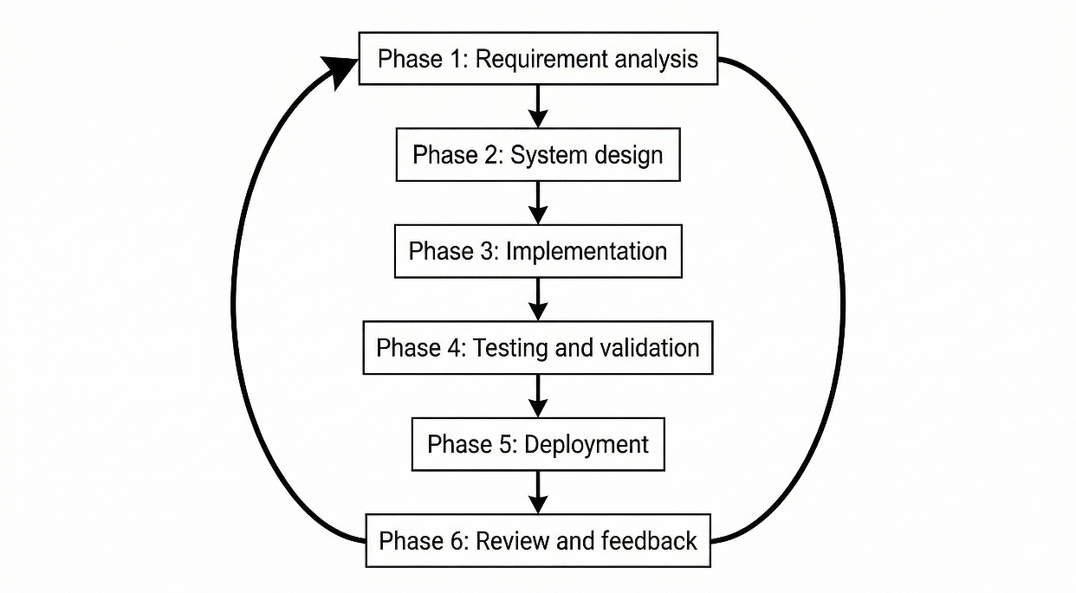
Figure 3.1: Iterative Workflow for Analytics Platform Development

Phase | Typical inputs | Key activities | Outputs / evidence artefacts (examples)
Phase 1: Requirement analysis | Vendor portal report views, exported files, parameter settings, stakeholder clarifications | Identify parameters and expected breakdowns; define output fields/totals; catalogue edge cases; draft data-to-report mapping; define acceptance criteria | Parameter matrix; output-field inventory; baseline export pack; acceptance checklist
Phase 2: System design | Phase 1 artefacts, replicated schema, constraints and non-functional requirements | Specify replication scope and join paths; define refresh boundary and late-correction handling; define API contract and export behaviour; define validation plan and test cases | Report specification template (Appendix A); API contract; data mapping; test plan; design diagram references
Phase 3: Implementation | Design artefacts, replicated datasets, acceptance criteria | Implement version-controlled report queries/rules; build API endpoint; implement parameter validation and formatting; add basic logging and error handling | Endpoint implementation; reproducible queries; sample outputs; execution logs
Phase 4: Testing and validation | Baseline exports, platform outputs, acceptance checklist | Compare outputs; investigate discrepancies; refine rules; run regression checks; record acceptance decisions and reconciliation results | Comparison evidence; discrepancy log; updated rule versions; validation sign-off
Phase 5: Deployment | Validated module, environment-ready checklist | Deploy to development environment; configure access controls; document release notes and rollback steps | Deployed endpoint/portal view; deployment checklist; release notes
Phase 6: Review and feedback | Deployed module, stakeholder feedback | Capture usability gaps and missing cases; triage defects vs enhancements; update acceptance criteria and test scenarios | Feedback log; change requests; revised acceptance criteria
Table 3.1: Phase-level inputs, activities, and evidence artefacts (per report module)

The phase descriptions in Sections 3.3.1 to 3.3.6 elaborate the responsibilities summarised in Table 3.1 and explain how each phase contributes to parity-driven report reconstruction and evidence retention.

Phase 1: Requirement Analysis (Document Analysis and Stakeholder Feedback)
Requirements are elicited through document analysis of vendor portal reports and exported files, together with stakeholder feedback and clarification from Finance and Operations users regarding business intent, expected breakdowns, and acceptance criteria for continuity reporting. Because vendor logic is treated as a black box, the project applies a reverse engineering perspective to infer business rules from observable inputs and outputs (Chikofsky & Cross, 1990). Black-box testing practices support this phase by enforcing comparable parameters (e.g., outlet and date range) for subsequent parity checks (Myers et al., 2011). In practical terms, this phase produces a parameter matrix (inputs, defaults, and constraints), an output-field inventory (including totals/subtotals and formatting expectations), and a baseline export pack that serves as the reference set for subsequent comparisons. Edge cases that can materially affect parity (e.g., voids, returns, split tenders, and rounding behaviour) are recorded as test scenarios to support repeatable validation as rules evolve.
Key outputs of Phase 1 therefore include a report-specific parameter list, an output-field inventory, a draft data-to-report mapping (candidate tables and join keys in the replicated schema), and an acceptance checklist describing what constitutes an acceptable parity match for the report. These artefacts provide the basis for both implementation planning and validation evidence retention in later phases.

Phase 2: System Design
System design translates Phase 1 requirements into design artefacts across the platform layers. At the replication and data-preparation level, this includes determining the minimum replication boundary for each targeted report by tracing required output columns and business rules back to the relevant source tables, join paths, and reference data. The replicated schema preserves a 1:1 table structure with the source database, but only the tables required for the targeted reports are selected for replication. In the current project context, transactional data replication is generally bounded from 2025 onward in line with organisational storage constraints, whereas reference tables are replicated in full. The design also defines refresh boundaries, rerun considerations, and the planned automation direction, where daily scheduled replication at midnight is intended for subsequent iterations.
At the semantic/API and portal layers, the design specifies both the report contract and the report presentation in a traceable manner. This includes endpoint naming, required and optional parameters (including defaults aligned to the portal workflow), response schema (fields and data types), output columns, totals/subtotals, sorting and formatting rules, and export behaviour aligned to vendor report structures. Report design also defines the use of reusable shared components and a common layout across the portal, while allowing report-specific configuration for parameters, column sets, and output behaviour. The design further establishes a validation plan by mapping acceptance criteria and edge-case scenarios to concrete test cases and evidence artefacts (e.g., baseline exports and comparison outputs). Design modelling artefacts (e.g., architecture diagrams, data flow, and simplified data model/ERD) are presented in Chapter 4, while detailed per-report templates are consolidated and maintained in Appendix A.

Phase 3: Implementation
Implementation follows a logic-first sequence: report logic is developed at the semantic/API layer and exercised using controlled parameters aligned to Phase 1 baseline exports. Where feasible, query prototypes are first validated against the replicated schema to confirm data availability, join correctness, and boundary handling, after which logic is stabilised into version-controlled queries and exposed through an API endpoint with a defined request/response contract. Implementation work also includes consistent parameter validation, deterministic output ordering where required for comparison, and export-ready formatting so that parity checks can be performed reliably against vendor exports. Basic logging and error handling are incorporated to support traceability of runs during iterative validation cycles.
Replication automation is treated as an operational enhancement after logic parity is established. In the current project stage, replication is executed using manual scripts; scheduling and automated rerun controls are planned for subsequent iterations.

Phase 4: Testing & Validation (Parity and Reconciliation)
Testing and validation are performed at both module and system levels. At the module level, parity validation is conducted by generating platform outputs using identical parameters to vendor exports and comparing results at the appropriate granularity (row-level where applicable and aggregate-level where exports group outputs). Comparisons are performed using consistent filtering and boundary rules, and discrepancies are investigated and resolved through iterative refinement of filters, joins, date handling, and edge-case treatment. To reduce regression risk, previously validated scenarios (including recorded edge cases) are rechecked after rule changes so that fixes for one report do not introduce unintended drift in another.
At the system level, reconciliation checks are applied to confirm cross-report consistency (e.g., alignment between sales totals and payment totals for the same reporting windows under defined rules). These checks operationalise data quality perspectives such as accuracy, completeness, and consistency (International Organization for Standardization, 2008; Wang & Strong, 1996). Validation artefacts (baseline exports, comparison outputs, and acceptance decisions) are retained to support repeatability.
In addition to parity and reconciliation validation, a basic operational performance evaluation will be conducted to assess usability under typical usage conditions. Response-time observations will be recorded for representative report queries using selected outlet and date-range parameters, including scenarios aligned with reporting-intensive windows (e.g., month-end reconciliation). Multiple runs will be performed under comparable conditions and observed response times will be compared against practical expectations for routine Finance and Operations workflows. The intent of this evaluation is to confirm operational acceptability rather than to conduct exhaustive benchmarking or load testing.

Phase 5: Deployment
Upon meeting validation criteria for a module, the corresponding API and portal changes are deployed to the target environment according to an environment-ready checklist. Deployment activities include configuration validation (e.g., database connectivity and access controls), version tagging and release documentation to support traceability of rule changes, and basic rollback considerations for changes that materially affect report outputs. As of Week 28, the warehouse, API service, and portal have been deployed to a cloud-hosted development environment to support iterative testing and stakeholder review. Subsequent deployment activities include introducing scheduled replication runs, configuring monitoring and rerun procedures, and publishing portal updates for intended user groups.

Phase 6: Review & Feedback
Feedback is collected from Finance and Operations users to identify usability issues, missing data elements, and any residual discrepancies observed during real workflows. Feedback is documented as traceable change requests and triaged into parity defects that require rule correction and enhancements that adjust workflows or presentation without changing core financial meaning. Where feedback changes acceptance criteria or reveals new edge cases, the iteration returns to Phase 1 for the affected module so that requirements artefacts are updated and the revised logic is validated again with retained evidence.
As shown in Figure 3.2, the high-level operational workflow of the proposed platform begins with data extraction and replication from the external POS environment, followed by ELT processing into the company-owned SQL Server replica, semantic/API-based report reconstruction, and final report delivery through the internal reporting portal to Finance and Operations users. This view links the development phases described above to the end-to-end technical flow implemented and validated during the project.
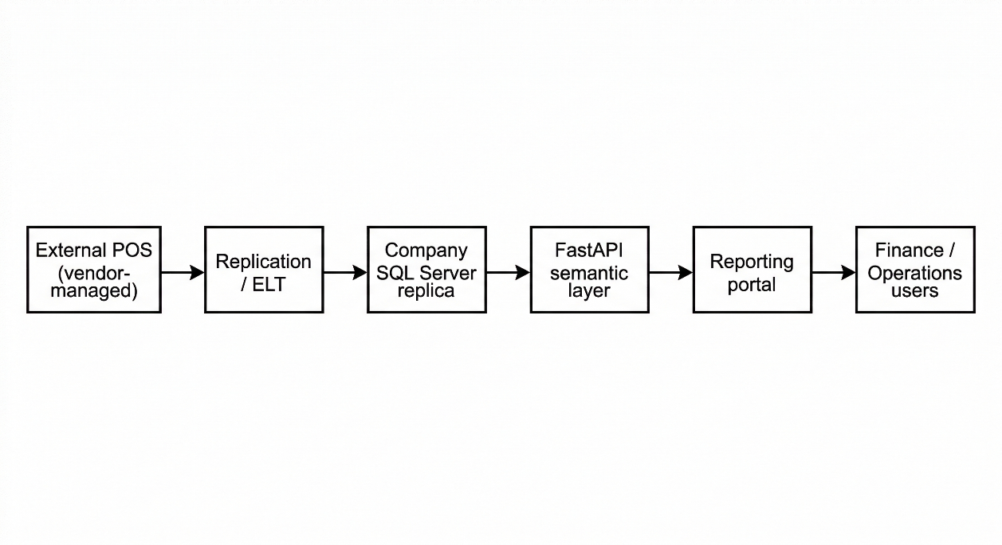
Figure 3.2: High-level system workflow (data replication to report delivery)

Project Schedule (Gantt Plan for FYPi1 and FYPi2)
For planning and tracking purposes, the overall project timeline is expressed as Weeks 1 to 28, where Weeks 1 to 14 correspond to SCSP 4233 (FYPi1) and Weeks 15 to 28 correspond to SCSP 4234 (FYPi2). Table 3.2 summarises the planned sequencing and the current status as of Week 28. The schedule indicates that the earlier part of the project emphasises problem formulation, literature review, and methodology/design preparation, while the later stages focus on replication foundations, report reconstruction, portal integration, deployment, and subsequent operational enhancements such as automation and performance evaluation. It also shows that, by Week 28, the project has completed the earlier planning-oriented work packages, established the manual replication foundation, and deployed the development environment, while report reconstruction and portal integration remain in progress.
Work package | Weeks (planned) | Key outputs | Status (as of Week 28)
Problem formulation and stakeholder alignment | 1–2 | Problem statement, scope draft, acceptance criteria outline | Completed
Literature review and synthesis | 1–6 | Chapter 2 draft with evidence-based justification | Completed (draft)
Methodology definition and design planning | 3–8 | Chapter 3 methodology; initial Chapter 4 design artefacts | Completed (draft)
Replication foundations (manual) | 5–12 | Replicated schema baseline; manual replication scripts | Implemented (manual; automation planned)
Report reconstruction iterations (15 reports) | 9–28 | Report APIs; parity validation artefacts | 7 of 15 implemented and validated
Portal development and integration | 13–28 | Report views; export workflow | 4 reports integrated
Cloud-hosted development deployment | 20–28 | Deployed development environment | Completed
Automation, monitoring, and rerun controls | 25–28 | Scheduler, logging, monitoring design | Planned for subsequent iterations
Performance evaluation (response-time) | 25–28 | Response-time evaluation plan and test windows | Planned for subsequent iterations
Table 3.2: Project schedule and status summary (Weeks 1–28)

System Requirement Analysis: Hardware and Software
The platform requirements are described at a practical level to support replication workloads, concurrent report queries, and operational monitoring in a cloud-hosted environment. Table 3.3 summarises the high-level hardware requirements, while Table 3.4 summarises the software components and their roles within the platform. Together, these tables indicate that the platform is designed around practical operational sufficiency rather than production-scale optimisation, and that final sizing should still be validated iteratively against replication scope, refresh cadence, and expected user concurrency during performance evaluation.

Hardware Requirements
At the hardware level, the platform requires sufficient compute, memory, storage, network stability, and environment availability to support replication, API serving, and stakeholder validation activities. As summarised in Table 3.3, the hardware requirements are framed around dependable execution of replication and ELT tasks, responsive report generation, and stable access for iterative stakeholder review.
Resource | Requirement (high-level) | Justification
Compute | Multi-core CPU capacity | Supports parallel replication/ELT tasks and concurrent API request handling.
Memory | Sufficient RAM for database and service workloads | Supports SQL Server caching and in-memory processing during report generation.
Storage | Low-latency storage (SSD-backed) with growth headroom | Supports replicated tables, indexes, logs, and export artefacts with predictable query performance.
Network | Stable connectivity between source, replica, and services | Required for extraction, loading, and portal access; impacts refresh time and report responsiveness.
Availability | Development environment availability aligned to stakeholder review | Supports iterative validation and reduces disruption during reporting windows.
Table 3.3: Hardware requirements (high-level)

Software Requirements
At the software level, the platform depends on a relational database, a Python-based ELT environment, an API framework, a frontend framework, and version control tooling. As summarised in Table 3.4, these components collectively support the end-to-end workflow of data replication, report logic reconstruction, portal-based report delivery, and traceable change management.
Component | Role in the platform | Notes
Microsoft SQL Server | Hosts the replicated transactional schema | Provides relational storage for replicated tables and report queries.
Python | Implements replication/ELT scripts and supporting utilities | Supports iterative development and operational scripting for extraction and loading.
SQLAlchemy + `pyodbc` | Database connectivity from Python | Provides a maintainable access layer to SQL Server via ODBC.
Microsoft ODBC Driver 17/18 | ODBC connectivity to SQL Server | Driver version depends on host environment configuration.
FastAPI | Semantic/API layer for report endpoints | Exposes reconstructed report logic as RESTful services (FastAPI, n.d.).
React + Node.js | Reporting portal frontend | Implements report parameter inputs, tabular display, and export workflow (React, n.d.).
Git | Version control for code and documentation | Supports traceability of changes to report logic and validation artefacts.
Table 3.4: Software requirements (high-level)

Summary
This chapter presented an iterative methodology for reconstructing vendor-aligned report logic, executing replication and ELT processes, and validating report-level parity through reconciliation-driven checks. Chapter 4 presents the analysis and design artefacts that operationalise this methodology for the proposed platform.

ANALYSIS AND DESIGN

Introduction
This chapter presents the analysis and design of the proposed Sales and Payment Analytics Platform. The chapter translates the problem statement and objectives into concrete requirements and design artefacts, including system analysis, system requirements, current system analysis, and detailed system design. The academic basis for the design choices (replication-first traceability, ELT, semantic layers, reconciliation, and iterative delivery) is grounded in Chapter 2 (see Table 2.3), while Chapter 3 describes the methodology used to execute and validate the proposed design.

System Analysis

Case Study Context (Continuity Reporting for Sales and Payments)
The case study concerns sales and payment reporting in a large-scale food and beverage (F&B) retail setting where transaction processing and reporting access are provided through an externally managed POS environment and reporting portal. Continuity reporting is operationally important for Finance (reconciliation and month-end closing) and Operations (outlet-level oversight), particularly when report access is time-sensitive. In this context, the core system problem is that reporting access is mediated through vendor-managed interfaces and exports, which can constrain ad hoc investigation and introduce operational risk when the portal is unavailable (see Chapter 2, Section 2.2.1).

Stakeholders and Role-Based View
Stakeholders are represented in a role-based manner to clarify reporting needs without asserting an official organisation chart.
Stakeholder group | Primary activities | Reporting needs (examples)
Finance users | Reconciliation, month-end closing, audit preparation | Daily totals, payment breakdowns, returns/adjustments visibility, export for reconciliation
Operations users | Outlet performance monitoring, operational oversight | Outlet-level daily summaries, trend visibility, payment mix, exception/return checks
Internal technical team | Platform maintenance and enhancements | Traceability, logging/monitoring, rerun support, controlled release of report rule changes
Table 4.1: Stakeholder groups and reporting needs (role-based view)

System Requirements Gathering Techniques
Requirements are derived through document analysis of vendor portal reports and exported files, together with stakeholder feedback and clarification sessions with Finance and Operations users. This approach is consistent with a black-box reporting environment where proprietary report rules must be inferred from observable inputs and outputs (see Chapter 2, Section 2.2.6). No survey instruments or formal interviews are claimed; the emphasis is on traceable artefacts (exports, parameter settings) and acceptance criteria agreed for continuity reporting.

Use Case Diagram
The principal interactions between user roles and the proposed platform can be summarised through a use case view. As shown in Figure 4.1, Finance and Operations users interact with the platform through six core use cases: access the report catalogue, select a report, apply report parameters, query the report output, review tabular results and totals, and export report outputs for reconciliation or operational follow-up. The internal technical team supports the platform through four operational use cases: execute replication refreshes, monitor runs and logs, rerun failed boundaries, and update report logic in a controlled manner. This use case view provides an analysis-level summary of the actor-system interactions before the more detailed design discussion in later sections.
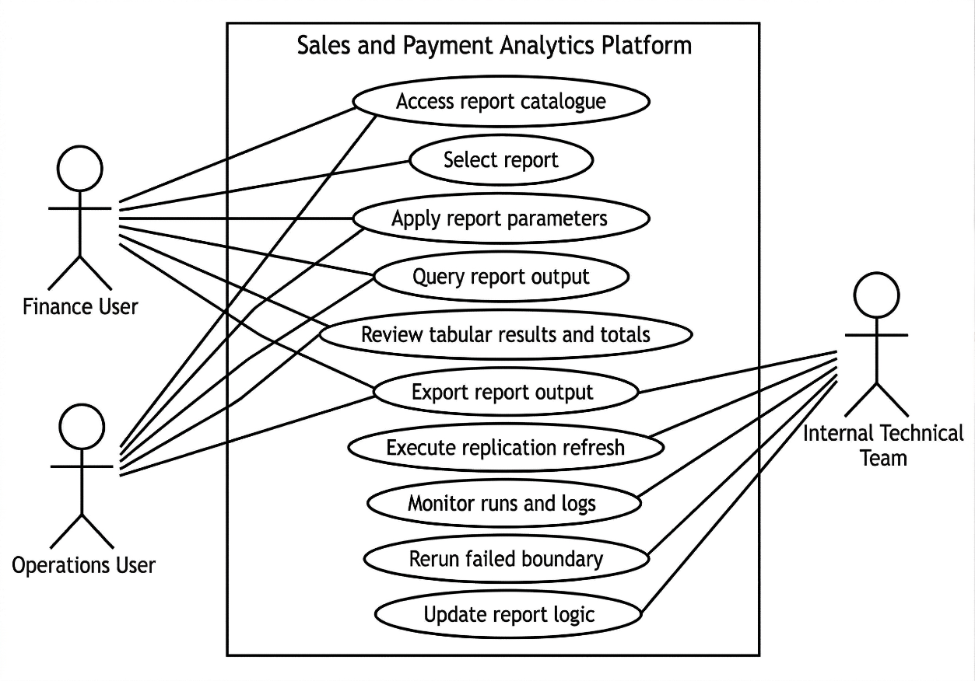
Figure 4.1: Use case diagram for the proposed Sales and Payment Analytics Platform (illustrative)

User Requirement Outcomes
The requirement-gathering activities described above produced more specific outcomes than a general need for "report access". For Finance and Operations users, the analysis indicated that the replacement platform must preserve the practical behaviour of the vendor portal: users need a familiar report catalogue, parameter-driven retrieval, consistent option sets for shared parameters, exact tabular outputs for checking, and exportable results that can be used directly in reconciliation and month-end workflows. The findings also indicate that continuity reporting is prioritised over exploratory analytics, which is why detailed tables, totals, and export functions are treated as core interface outcomes rather than optional features.
For the internal technical team, the main outcomes concern maintainability and traceability. The platform must preserve source-aligned replicated data, support vendor-equivalent rule implementation through SQL queries executed by the semantic/API layer, reuse common parameter and export logic across reports where possible, and provide controlled rerun and monitoring support when replication or validation issues occur. These outcomes provide the practical basis for the functional and non-functional requirements formalised in Section 4.3 and for the detailed design decisions presented in Sections 4.5.3 to 4.5.6.

System Requirements

Functional Requirements (FR)
The functional requirements are summarised in Table 4.2.
ID | Functional requirement
FR1 | The system shall replicate relevant sales and payment transactional datasets from the external POS environment into a company-owned database on a scheduled basis.
FR2 | The system shall generate the targeted sales and payment reports based on the replicated datasets.
FR3 | The system shall provide report filtering by report-specific parameters (at minimum outlet and date range).
FR4 | The system shall support exporting report outputs (e.g., tabular export) to support reconciliation workflows.
FR5 | The system shall expose report logic through an API layer to decouple the frontend from database schema changes.
Table 4.2: Functional requirements for the proposed platform

Non-Functional Requirements (NFR)
The non-functional requirements are summarised in Table 4.3.
ID | Non-functional requirement
NFR1 | Data fidelity and traceability: report outputs shall remain traceable to replicated source records and support reconciliation checks.
NFR2 | Availability: the platform shall provide an alternative reporting path when the vendor portal is unavailable.
NFR3 | Performance (operational usability): report responses shall be delivered within an acceptable time for user workflows during reporting-intensive periods (e.g., month-end closing).
NFR4 | Security: the system shall operate as a read-only reporting platform and implement appropriate access controls.
NFR5 | Maintainability: report logic shall be structured to support iterative updates when edge cases or rule changes are discovered.
Table 4.3: Non-functional requirements for the proposed platform

Constraints and Assumptions
The platform is designed under several constraints and assumptions. Access to the external POS environment is restricted and may be read-only. The current project phase targets sales and payment reporting for a defined set of high-priority reports, and the platform does not implement write-back to the vendor POS system. The replication cadence is designed to support operational reporting needs rather than real-time transactional processing. Design decisions in this chapter therefore prioritise traceability, repeatability, and operational controls for continuity reporting (see Chapter 2, Sections 2.2.3–2.2.7).

Current System Analysis
The current reporting workflow relies on a vendor-managed reporting portal as the primary interface for sales and payment reports. Users typically select a report, apply parameters (e.g., outlet and date range), and export results for reconciliation activities. This workflow can constrain ad hoc analysis because users cannot freely query underlying transactional records, and operational reporting can be disrupted if portal access is degraded during reporting-intensive periods. Issue resolution is also dependent on vendor support processes, which can misalign with internal reporting timelines (see Chapter 2, Section 2.2.1).
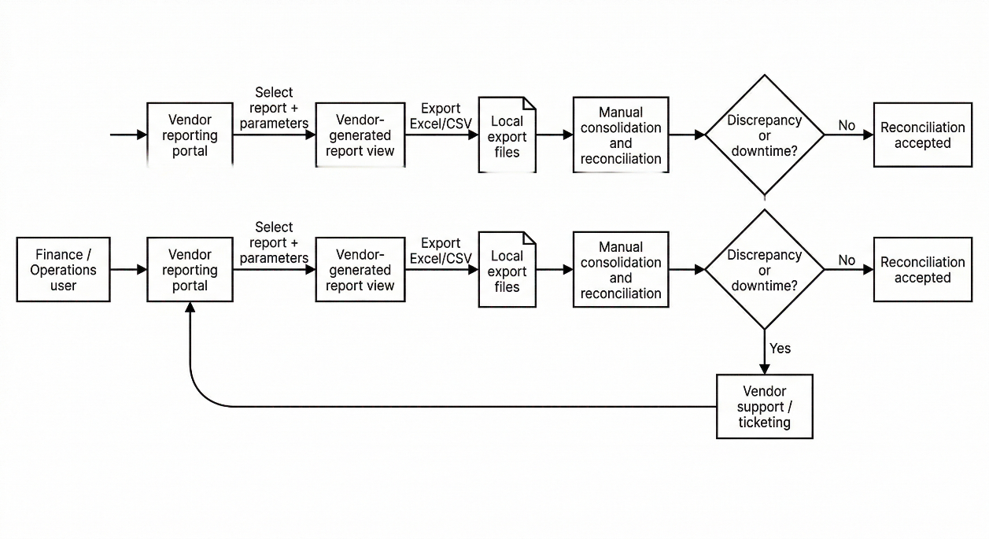
Figure 4.2: Current vendor-dependent reporting workflow (simplified)

System Design

System Architecture
The proposed system is organised as an end-to-end analytical flow comprising six connected stages: vendor-managed POS data sources, selective replication and ELT, a company-owned SQL Server replica, a semantic/API layer, a reporting portal, and Finance and Operations users. This structure preserves source-aligned data in the replica while centralising report rules, validation logic, and delivery behaviour at the FastAPI service layer, consistent with the replication- and semantic-layer rationale discussed in Chapter 2, Sections 2.2.4-2.2.5.
As shown in Figure 4.3, the architecture begins with vendor-managed transactional data and vendor report exports, which feed a selective, boundary-based replication and ELT process into the company-owned SQL Server replica. The FastAPI semantic layer then applies report rules and validation over the replicated data before the reporting portal presents report lists, parameter-driven retrieval, tabular outputs, and export functions to Finance and Operations users. In this way, the figure illustrates how continuity reporting is delivered through a company-controlled path while preserving separation between data acquisition, storage, business-rule processing, and presentation.
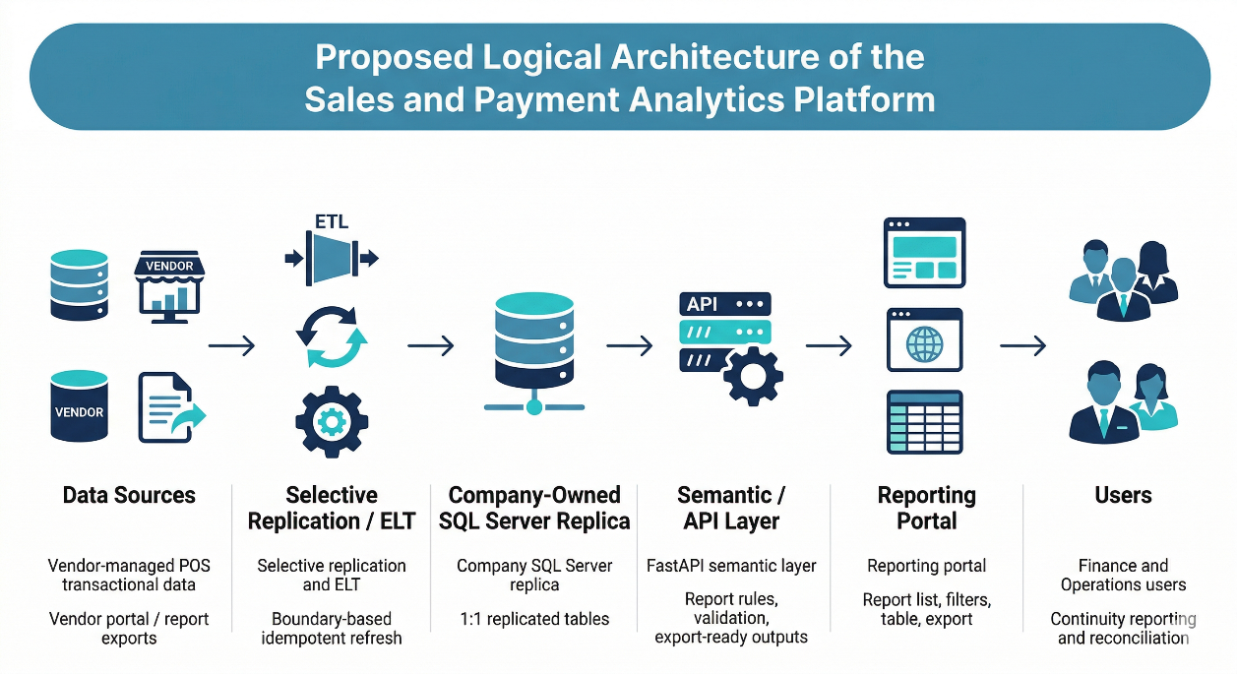
Figure 4.3: Proposed logical architecture of the analytics platform

Component Explanations
Table 4.4 summarises each component's responsibility and key design considerations. These component-level responsibilities are aligned with the literature reviewed in Chapter 2, particularly the discussions on replication-based analytical stores and ELT workflows (Sections 2.2.2-2.2.4), semantic layers and service interfaces (Section 2.2.5), and workflow/interface considerations for operational reporting portals (Section 2.4). Table 2.3 provides the consolidated synthesis linking these design choices to their academic rationale.
Component | Responsibility | Key design considerations
External POS environment | Source of transactional records and vendor report exports | Access constraints; parameter consistency; late corrections
Replication / ELT scripts | Extract and load source data into the replica | Idempotent refresh boundaries; logging; rerun controls; error handling
SQL Server replica | Store 1:1 replicated tables and support report queries | Traceability; indexing strategy; retention boundaries; operational monitoring
FastAPI semantic layer | Encapsulate report rules and expose stable report endpoints | Versioned business rules; consistent metric definitions; parameter validation; authentication/authorisation
Reporting portal | Provide continuity access to reports and exports | Usability during month-end; consistent filtering; totals/subtotals; export fidelity
Table 4.4: Component responsibilities and design considerations

Data Engineering and API Design

Data Sources and Replication Boundary
The primary data source is the vendor-managed POS transactional database, which is accessed for read-only replication into the company-owned SQL Server environment. At a logical level, the source data required by the targeted reports can be grouped into transaction-header records, line-item records, payment or tender records, and supporting master/reference data. Transaction-header data provides the reporting grain and status context for each sale, line-item data supports item-level analysis and quantity or amount breakdowns, payment data supports payment-type reporting and reconciliation, and master/reference data such as outlet/location and item/product attributes is required to interpret and group transactional records consistently. Because physical table and column names are vendor-specific, the design documents these sources conceptually while preserving a 1:1 structural representation in the replica for traceability. The main conceptual entities used by the targeted reports are summarised later in Table 4.5.
Replication boundaries are defined report by report by tracing required output columns and business rules back to the minimum set of source tables needed for reconstruction. Within the current project scope, transactional data replication is generally bounded from 2025 onward in line with organisational storage constraints, whereas reference and master tables are replicated in full because they are comparatively smaller and are needed to interpret transactional records consistently across reporting periods. This selective but fidelity-preserving boundary supports operational reporting windows while allowing late corrections to be refreshed during subsequent runs.

Refresh Cadence and Idempotent Load Pattern
The ELT workflow is designed to refresh operational data on a scheduled basis and to account for late corrections (e.g., late voids, adjustments, and return postings). In the current project stage, refresh execution remains manual, while the planned operational design is to perform scheduled refreshes at midnight each day. This design operationalises the ELT and idempotent-load principles discussed in Chapter 2, Section 2.2.3, where controlled load boundaries and deterministic reruns are identified as the basis for repeatable refresh cycles. Within each refresh boundary, existing rows for the affected window are deleted from the replica and then re-inserted from a fresh extract. This ensures that repeating the same boundary yields a consistent replicated state and supports recovery when extraction or load failures occur.
As illustrated in Figure 4.4, the refresh and report-serving sequence can be described in two stages. During the refresh stage, the ELT process first extracts source transactions from the POS environment for a defined boundary window, then removes previously replicated rows for the same boundary from the SQL Server replica, inserts the refreshed rows, and performs post-load checks such as row-count comparison and sampling-based verification. During the report-serving stage, the portal submits a report request with user-specified parameters, the API queries the refreshed replica and applies semantic rules, and the resulting rows, totals, and export-ready output are returned to the portal. This separation clarifies that replication and report serving are linked operationally but remain distinct responsibilities within the overall platform design.
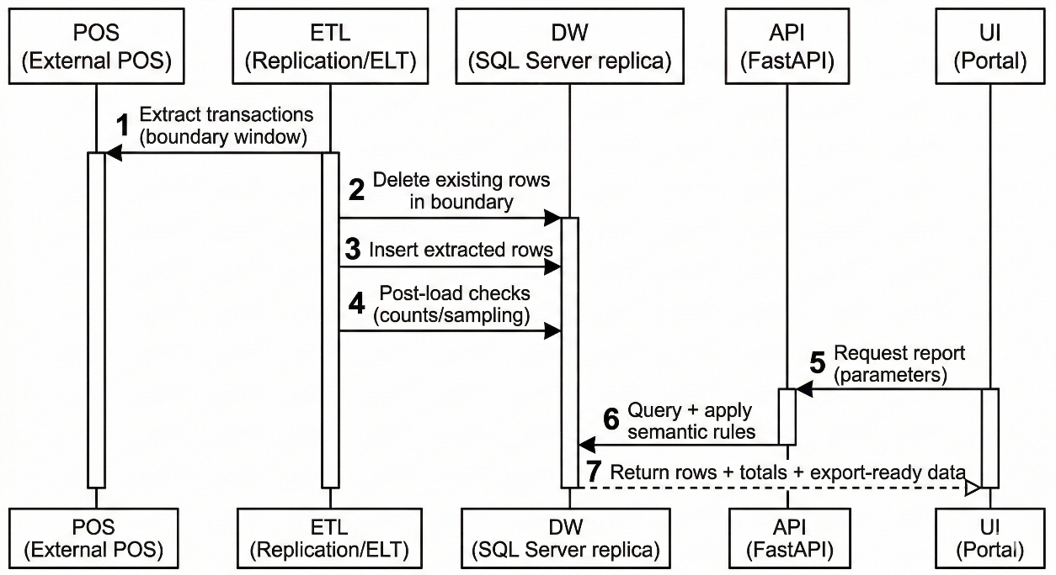
Figure 4.4: Proposed boundary-based refresh and report-serving sequence (illustrative)

Error Handling, Logging, and Monitoring
Operational controls are designed to support reliability and recovery. These controls include logging extraction and load outcomes (record counts, durations, and errors), post-load validation checks (e.g., row-count comparisons and sampling-based checks), and rerun capability for specific tables or boundaries without manual cleanup. This design is consistent with the discussion in Chapter 2, Sections 2.2.3 and 2.2.4, where idempotent load boundaries, operational controls, and recovery-oriented replication practices are identified as important for maintaining a trusted replicated state. Monitoring is intended to surface failed runs and to support repeatable recovery steps, which also aligns with the validation and recovery emphasis described in Chapter 3, Section 3.3.4.

API Endpoint Pattern and Semantic Layer Responsibilities
The API layer acts as a semantic layer that encapsulates reconstructed business rules and provides a stable interface to the reporting portal. Endpoints follow a consistent report pattern (illustrative), such as:
GET /reports/<report_name>
?start_date=YYYY-MM-DD
&end_date=YYYY-MM-DD
&location_keys=...(optional)
&... (other optional parameters)
For each endpoint, the design specifies required and optional parameters (including defaults aligned to the portal workflow), the output schema (fields, totals/subtotals, and formatting rules), and the validation approach (parity checks against vendor exports and cross-report reconciliation). This design directly reflects the semantic-layer and service-interface concepts discussed in Chapter 2, Section 2.2.5: replicated data are retained close to source structure for traceability, while report-specific business rules, derived fields, and delivery logic are centralised at the API layer. The API adopts a RESTful interface style to support standardised access and to decouple report consumption from underlying storage design, thereby keeping report logic more maintainable, versioned, and auditable.

Security Considerations
The platform is designed as a read-only reporting environment. The API should enforce authentication and authorisation appropriate to organisational policy. Access control is intended to ensure that only authorised users can retrieve reports and that query parameters are validated to prevent unintended exposure of data.

Report Logic Reconstruction Pattern and Representative Examples
Report reconstruction follows a repeatable workflow: define inputs (parameters and filters), identify contributing replicated datasets, implement vendor-aligned business rules at the semantic layer, aggregate and format outputs into a stable schema, and validate parity against vendor exports (Chapter 3, Sections 3.3.1 and 3.3.4). To keep the main chapter concise, only three representative examples are summarised below. Detailed report specification templates for the full set of fifteen targeted reports are consolidated in Appendix A (AppendixA-ReportSpecifications.md) and are completed iteratively as modules are implemented and validated.
Example 1: Daily Sales Summary (representative). This report aggregates sales totals for a selected outlet and business date range. Key reconstruction concerns include transaction inclusion criteria (e.g., completed vs voided), granularity (daily and outlet totals), and consistent handling of adjustments such as refunds.
Example 2: Payment Type (All Payment) (representative). This report provides a breakdown of payment collections by store and period, grouped by dimensions such as order source, payment method, device, card type, and reference. Key reconstruction concerns include split payments, mapping payment records to the correct sales identifiers and dates, and ensuring totals reconcile under defined rules.
Example 3: Sales Return Report (representative). This report retrieves return transactions (negative sales) for a selected date range and outlet scope. Key reconstruction concerns include return identification criteria, consistent computation of return amounts, traceability fields (e.g., sales number and original sales reference), and portal-equivalent filter behaviour.

Database Design
The data design adopts a 1:1 replication strategy, where the company-owned database mirrors relevant transactional tables from the external POS environment. This strategy prioritises fidelity and traceability to support reconciliation and parity validation, which is consistent with the replication and consistency considerations discussed in Chapter 2, Sections 2.2.2-2.2.4. It is also aligned with the database-design and schema-on-read discussion in Chapter 2, Section 2.2.5, where duplicated transactional data are retained close to source structure for traceability, while report-specific calculations and derived logic are handled separately at the semantic/API layer.
As illustrated in Figure 4.5, the conceptual model centres on sales headers, sales items, payments, and supporting reference entities such as location and item master data. This model is intended to show the main reporting entities and relationships at a conceptual level rather than to expose vendor-specific physical table names.
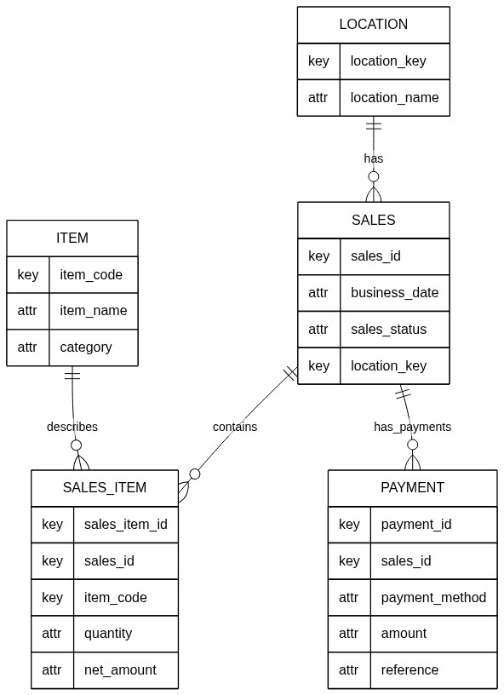
Figure 4.5: Simplified conceptual data model for sales and payment reporting (illustrative)

Table 4.5 summarises the conceptual entities required by the targeted reports. Physical table names and column names in the replicated schema are vendor-specific; the design intent is to preserve a 1:1 representation while documenting join paths and key attributes used in report logic.
Entity | Purpose in reporting | Representative attributes (conceptual)
Sales (header) | Defines the reporting grain for sales totals and status handling | Sale identifier; business date; outlet/location key; sales status; totals
Sales item (line) | Supports item-level reporting and return/adjustment detection | Sale identifier; item code/name; quantity; net amount; tax fields
Payment | Supports payment type breakdown and reconciliation | Sale identifier; payment method; amount; device/reference fields
Location | Maps location identifiers to outlet names | Location key; location name; hierarchy attributes (if available)
Item master | Provides item metadata and grouping fields | Item code/name; category/group/division attributes
Table 4.5: Conceptual data dictionary (summary)

Business Rule Reconstruction for the Fifteen Targeted Reports
Although the replicated database preserves source-aligned transactional structures, the business rules for the fifteen targeted sales and payment reports are reconstructed and applied within the semantic/API layer rather than embedded in the storage layer. This separation is consistent with Chapter 2, Section 2.2.5, where duplicated data are retained for traceability while report-specific logic is centralised above the database layer for maintainability and auditability.
The semantic/API design supports the fifteen targeted reports through a common service pattern. Each report is exposed through a dedicated endpoint, but follows a shared response structure based on flat-list outputs, common parameter parsing behaviour, and consistent export handling. Shared parameter logic is reused where reports expose the same option sets, while report-specific extensions allow additional filters such as item division, group name, or department when required.
In this project, business-rule reconstruction refers to inferring vendor-equivalent reporting rules from observed portal outputs and implementing those rules as SQL queries executed by FastAPI over the 1:1 replicated data. The semantic/API layer therefore applies report-specific selection, grouping, aggregation, and formatting logic without changing the underlying replicated structure. Appendix A documents the detailed per-report specifications for the fifteen targeted reports, including rule inputs, parameters, expected outputs, and validation scope. Within the main design chapter, the emphasis is therefore on the shared reconstruction pattern and service-layer responsibilities rather than repeating each individual report specification in full.

Interface Design
The portal is designed to mirror the existing user workflow for continuity reporting while providing consistent filtering and export behaviour. The primary interaction is: authenticate, select report, set parameters (outlet/date range and report-specific filters), view results with totals/subtotals, and export for reconciliation.
As illustrated in Figure 4.6, the report-list view is designed to support report discoverability and selection through a structured catalogue of available reports. This interface allows users to identify the required report quickly, recognise its reporting purpose from the accompanying description, and navigate into the relevant reporting screen without relying on vendor-managed menus. In this way, the report-list view contributes to the project objective of improving accessibility for Finance and Operations users within a company-controlled reporting environment.
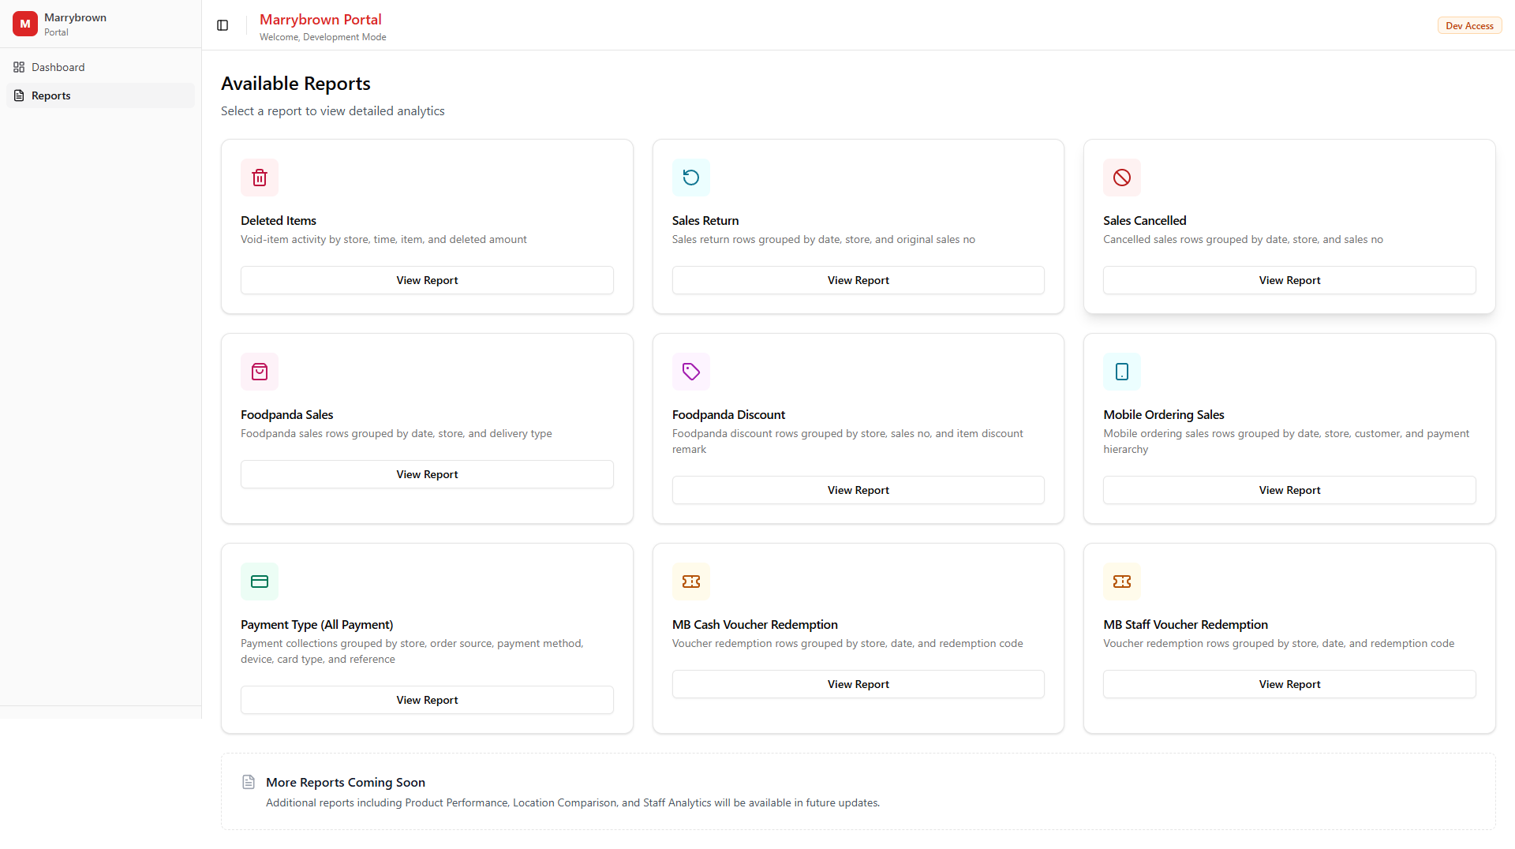
Figure 4.6: Report list view prototype (illustrative)

As illustrated in Figure 4.7, the reporting view combines parameter controls, query execution, summary indicators, tabular output, and export actions within a single workflow. This design enables users to specify report parameters, retrieve vendor-aligned outputs, inspect key totals or subtotals, and export the result for reconciliation or further review. Rather than prioritising chart-heavy dashboards, the current interface emphasises summary cards and detailed tabular presentation because the project objective is continuity reporting and parity-aligned operational access rather than exploratory visual analytics.
In the current prototype, analytical presentation is therefore centred on summary indicators and tabular results, while chart-based views are treated as secondary because the targeted reports prioritise exact values, parameter-driven retrieval, and exportable outputs for reconciliation.
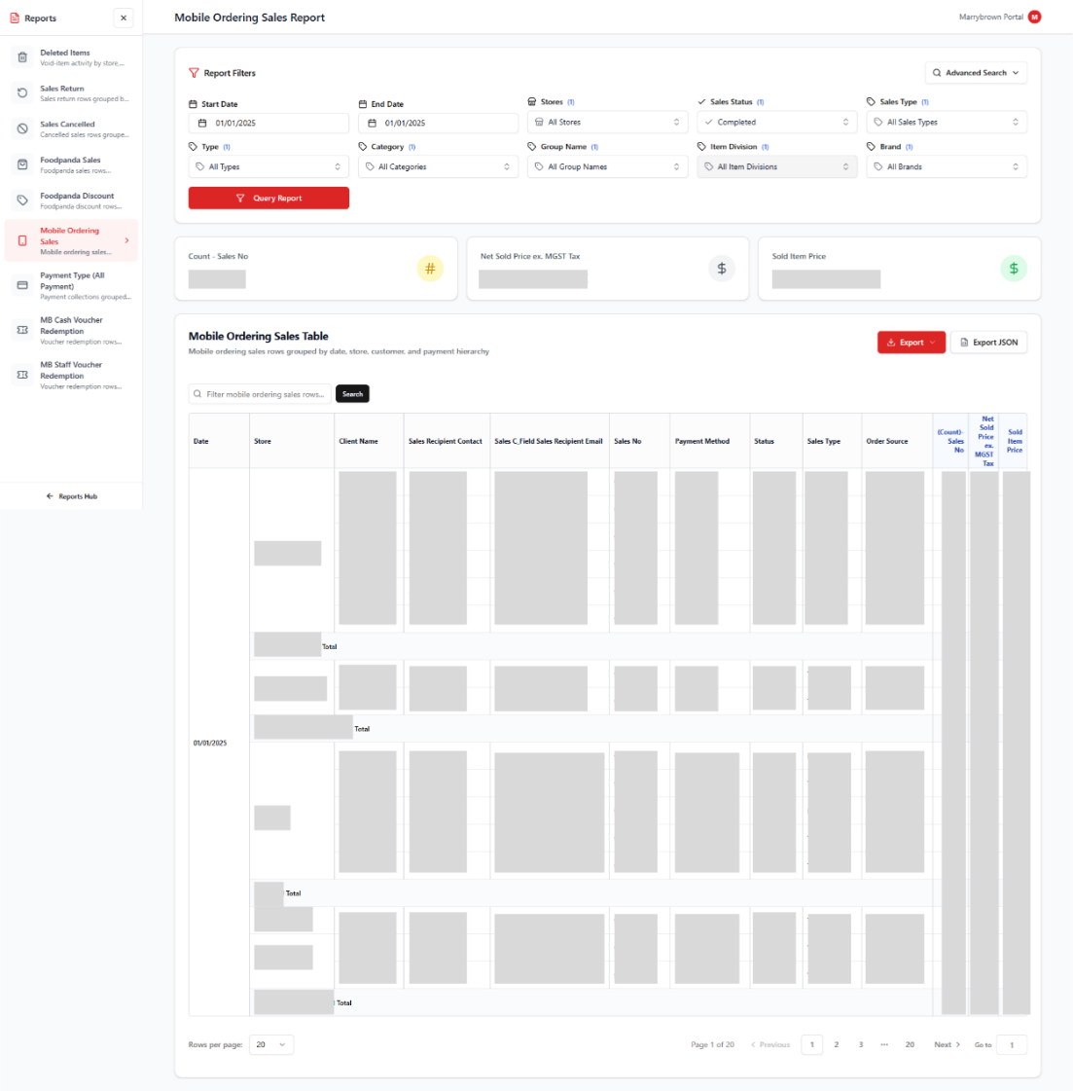
Figure 4.7: Reporting view prototype (illustrative)
Figure 4.8 provides a simplified workflow view of the overall portal interaction, linking login, report discovery, report selection, parameter entry, result inspection, export, and downstream reconciliation. While Figures 4.6 and 4.7 show specific interface states, Figure 4.8 summarises the intended end-to-end navigation path so that the relationship between report selection and report consumption can be understood at a glance.
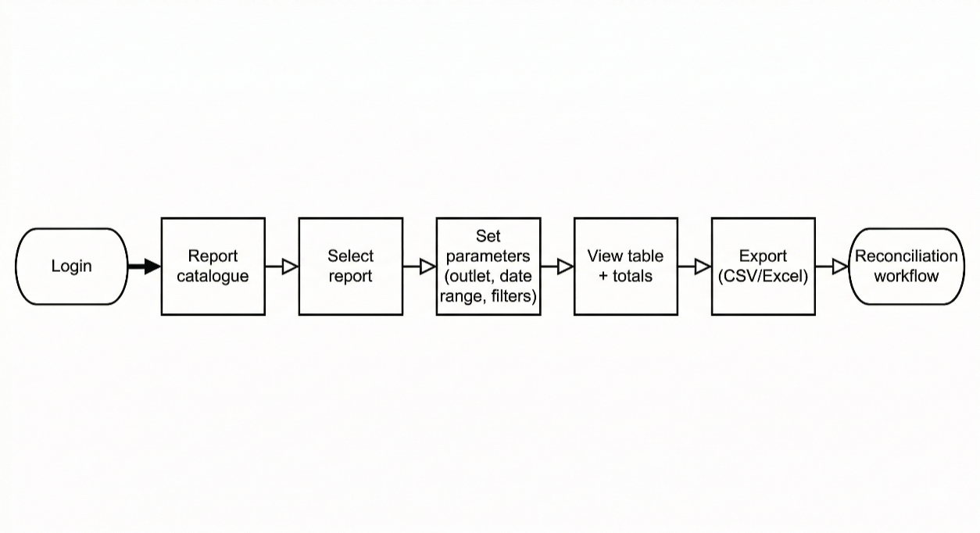
Figure 4.8: Portal navigation and report workflow (illustrative)

Interface design requirements prioritise consistent parameter controls across reports (with report-specific extensions), tabular presentation aligned to expected vendor export structures, and export outputs that support downstream reconciliation. These priorities are consistent with the workflow and interface considerations for operational reporting portals discussed in Chapter 2, Section 2.4. Portal design details are refined iteratively based on stakeholder feedback during validation cycles (see Chapter 3, Section 3.3.6).

Summary
This chapter presented the system analysis, requirements, current system workflow, and the proposed design for the analytics platform. The design emphasises traceability, parity validation, and continuity reporting through replication-first data management, a semantic/API layer for report logic, and a portal interface that supports export-driven reconciliation. The next stage of work is to continue implementing and validating the remaining targeted reports and to introduce replication automation and operational monitoring as described in Chapter 3.

REFERENCES
Armbrust, M., Fox, A., Griffith, R., Joseph, A. D., Katz, R., Konwinski, A., Lee, G., Patterson, D., Rabkin, A., Stoica, I., & Zaharia, M. (2010). A view of cloud computing. *Communications of the ACM, 53*(4), 50-58. https://doi.org/10.1145/1721654.1721672

Azzabi, S., Alfughi, Z., & Ouda, A. (2024). Data lakes: A survey of concepts and architectures. *Computers, 13*(7), 183. https://doi.org/10.3390/computers13070183

Badger, L., Grance, T., Patt-Corner, R., & Voas, J. (2012). *Cloud computing synopsis and recommendations* (NIST Special Publication 800-146). National Institute of Standards and Technology. https://doi.org/10.6028/NIST.SP.800-146

Batini, C., & Scannapieco, M. (2006). *Data quality: Concepts, methodologies and techniques*. Springer. https://doi.org/10.1007/3-540-33173-5

Beck, K., Beedle, M., van Bennekum, A., Cockburn, A., Cunningham, W., Fowler, M., Grenning, J., Highsmith, J., Hunt, A., Jeffries, R., Kern, J., Marick, B., Martin, R. C., Mellor, S., Schwaber, K., Sutherland, J., & Thomas, D. (2001). *Manifesto for agile software development*. Agile Manifesto. https://agilemanifesto.org/

Chikofsky, E. J., & Cross, J. H. (1990). Reverse engineering and design recovery: A taxonomy. *IEEE Software, 7*(1), 13–17. https://doi.org/10.1109/52.43044

FastAPI. (n.d.). *FastAPI documentation*. Retrieved March 2, 2026, from https://fastapi.tiangolo.com/

Few, S. (2012). *Use-based types of quantitative display*. Visual Business Intelligence Newsletter. Perceptual Edge. https://www.perceptualedge.com/articles/visual_business_intelligence/types_of_quantitative_display.pdf

Fielding, R. T. (2000). *Architectural styles and the design of network-based software architectures* (Doctoral dissertation, University of California, Irvine). https://ics.uci.edu/~fielding/pubs/dissertation/top.htm

Inmon, W. H. (2005). *Building the data warehouse* (4th ed.). Wiley.

International Organization for Standardization. (2008). *ISO/IEC 25012:2008 - Software engineering - Software product Quality Requirements and Evaluation (SQuaRE) - Data quality model*. https://www.iso.org/standard/35736.html

Jansen, W., & Grance, T. (2011). *Guidelines on security and privacy in public cloud computing* (NIST Special Publication 800–144). National Institute of Standards and Technology. https://doi.org/10.6028/NIST.SP.800-144

Kimball, R., & Caserta, J. (2004). *The data warehouse ETL toolkit: Practical techniques for extracting, cleaning, conforming, and delivering data*. Wiley.

Kimball, R., & Ross, M. (2013). *The data warehouse toolkit: The definitive guide to dimensional modeling* (3rd ed.). Wiley.

Kleppmann, M. (2017). *Designing data-intensive applications: The big ideas behind reliable, scalable, and maintainable systems*. O'Reilly Media.

Mell, P., & Grance, T. (2011). *The NIST definition of cloud computing* (NIST Special Publication 800-145). National Institute of Standards and Technology. https://doi.org/10.6028/NIST.SP.800–145

Microsoft. (2026). *Paginated reports in the Power BI service*. Microsoft Learn. https://learn.microsoft.com/en-us/power-bi/explore-reports/end-user-paginated-report

Myers, G. J., Sandler, C., & Badgett, T. (2011). *The art of software testing* (3rd ed.). Wiley.

Oracle. (2023). *Oracle MICROS Reporting and Analytics user guide* (Release 9.0). https://docs.oracle.com/cd/E71871_01/doc.90/e72023.pdf

Pressman, R. S., & Maxim, B. R. (2014). *Software engineering: A practitioner's approach* (8th ed.). McGraw-Hill Education.

React. (n.d.). *React documentation*. Retrieved March 2, 2026, from https://react.dev/

Schwaber, K., & Sutherland, J. (2020, November). *The Scrum guide: The definitive guide to Scrum: The rules of the game*. Scrum Guides. https://scrumguides.org/scrum-guide.html

Shneiderman, B. (1996). *The eyes have it: A task by data type taxonomy for information visualizations*. In *Proceedings of the IEEE Symposium on Visual Languages* (pp. 336-343). https://www.cs.umd.edu/~ben/papers/Shneiderman1996eyes.pdf

Sommerville, I. (2015). *Software engineering* (10th ed.). Pearson.

Wang, R. Y., & Strong, D. M. (1996). Beyond accuracy: What data quality means to data consumers. *Journal of Management Information Systems, 12*(4), 5–33. https://doi.org/10.1080/07421222.1996.11518099

Appendix

Appendix A: Report Specifications
This appendix organises report-level specifications for the 15 targeted sales and payment reports. As of Week 28 of the internship, seven report APIs have been implemented and validated, while the remaining reports are planned for subsequent iterations. Where a specification is incomplete, fields are marked as [TBD] and will be completed iteratively as the corresponding module is implemented and validated.

A.1 Specification Template (per report)
Field | Description
Report name | [TBD]
Business purpose | [TBD]
Primary users | [TBD]
Parameters | [TBD] (required/optional, defaults)
Output (summary) | [TBD] (key fields, totals/subtotals)
Data sources | [TBD] (replicated tables/modules)
Key business rules | [TBD] (filters, inclusion/exclusion, edge cases)
Validation approach | [TBD] (parity checks, reconciliation rules, acceptance criteria)
Implementation status | [TBD] (e.g., planned; implemented and validated)
Evidence artefacts | [TBD] (e.g., vendor export filenames, internal API documentation)
Table A.1: Report specification template fields

A.2 Target Report Index (15 reports)
This index lists the 15 targeted reports and provides a convenient place to track implementation and validation status during iterative development.
ID | Report | Status (Week 28) | Notes / Evidence
R01 | Daily Sales Summary | Implemented and validated | Internal API documentation (confidential; not included in this report).
R02 | Payment Type (All Payment) | Implemented and validated | Internal API documentation (confidential; not included in this report).
R03 | Sales Return Report | Implemented and validated | Internal API documentation (confidential; not included in this report).
R04 | Sales Cancelled Report | Implemented and validated | Validation artefacts retained (baseline exports and comparison outputs).
R05 | DELETED Items Report | Planned | [TBD]
R06 | Sale Delivery (By Sales Type) Ex Tax Calculation | Implemented and validated | Validation artefacts retained (baseline exports and comparison outputs).
R07 | MB Cash Voucher (with Barcode) Redemption Report | Implemented and validated | Validation artefacts retained (baseline exports and comparison outputs).
R08 | MB Staff E-Voucher RM 20 & MB CASH VOUCHER RM10 (with Barcode) Redemption Report | Implemented and validated | Validation artefacts retained (baseline exports and comparison outputs).
R09 | Product Mix Report | Planned | [TBD]
R10 | Discount Remark Report | Planned | [TBD]
R11 | Delivery-FoodPanda,Grabfood,ShopeeFood | Planned | [TBD]
R12 | Foodpanda Sales | Planned | [TBD]
R13 | Foodpanda Discount | Planned | [TBD]
R14 | Mobile Ordering Sales | Planned | [TBD]
R15 | Pickup & Declaration Report | Planned | [TBD]
Table A.2: Target report index (15 reports) and status summary (Week 28)

A.3 Report Specifications (to be completed iteratively)

R01: Daily Sales Summary
Field | Description
Report name | Daily Sales Summary
Business purpose | To provide a daily, outlet-level summary of sales and profit figures for operational monitoring and finance reconciliation, supporting continuity when the vendor portal is unavailable.
Primary users | Finance and Operations (reporting and reconciliation users).
Parameters | Business date range (required); optional outlet/location filter list; optional sales status filters aligned with baseline portal behaviour.
Output (summary) | Per business date and outlet: sales total and profit total, with optional grand totals across the selected scope.
Data sources | Replicated sales transactions and cost/profit attributes (where available), plus outlet/location reference data.
Key business rules | Business date is used for scoping; status selection follows baseline portal logic; returns and cancellations are treated consistently with baseline behaviour; totals are computed over the filtered set.
Validation approach | Parity validation against vendor exports (see Chapter 3 Section 3.3.4).
Implementation status | Implemented and validated (Week 28).
Evidence artefacts | Internal API documentation and validation artefacts retained (confidential; not included in this report).
Table A.3: Report specification fields for R01 (Daily Sales Summary)

R02: Payment Type (All Payment)
Field | Description
Report name | Payment Type (All Payment)
Business purpose | To summarise collections by payment method for the chosen period and outlets, supporting cash-up and payment reconciliation activities.
Primary users | Finance and Operations (payment reconciliation users).
Parameters | Business date range (required); optional outlet/location filter list; optional sales status filters; optional payment status filter (defaults to saved/posted payments).
Output (summary) | Collection totals grouped by payment method (and optionally by outlet), including overall total collection for the selected scope.
Data sources | Replicated payment transactions linked to sales and outlet/location records, plus payment method reference or mapping logic.
Key business rules | Split payments are allocated per sale; only qualifying payment statuses are included; sales status filters exclude void/cancelled records as appropriate; payment method categories are normalised to match baseline portal groupings.
Validation approach | Parity validation against vendor exports (see Chapter 3 Section 3.3.4).
Implementation status | Implemented and validated (Week 28).
Evidence artefacts | Internal API documentation and validation artefacts retained (confidential; not included in this report).
Table A.4: Report specification fields for R02 (Payment Type (All Payment)

R03: Sales Return Report
Field | Description
Report name | Sales Return Report
Business purpose | To list returned items and transactions within the selected period, enabling audit, inventory adjustment support, and reconciliation of return values against baseline exports.
Primary users | Finance and Operations (exception review and reconciliation), with secondary use by store operations.
Parameters | Business date range (required); optional outlet/location filter list; optional sales status filters; optional item classification filters (type, category, group, division).
Output (summary) | Row-level return entries including outlet, date, return document or sale reference, original sale reference (where applicable), item identifier and name, quantity, and net return amount.
Data sources | Replicated return transactions linked to original sales where applicable, plus item master and outlet/location reference data.
Key business rules | Only return-type transactions are included; item filters follow baseline portal semantics; row grouping and merge behaviour is aligned with the portal output; net return amount follows the baseline calculation and normalisation rules.
Validation approach | Parity validation against vendor exports (see Chapter 3 Section 3.3.4).
Implementation status | Implemented and validated (Week 28).
Evidence artefacts | Internal API documentation and validation artefacts retained (confidential; not included in this report).
Table A.5: Report specification fields for R03 (Sales Return Report)

R04: Sales Cancelled Report
Field | Description
Report name | Sales Cancelled Report
Business purpose | To provide an audit trail of cancelled or voided sales within the selected period, supporting internal control checks and exception review.
Primary users | Finance and Operations (audit and exception review users).
Parameters | Business date range (required); optional outlet/location filter list; optional item classification filters (type, category, group, division).
Output (summary) | Cancelled sale entries including outlet, date, sale reference, quantity, net sold value, and cancellation metadata (cancelled by, remark, cancellation date and location).
Data sources | Replicated sales transactions with cancellation markers and related metadata, plus outlet/location and item reference data (where required by filters).
Key business rules | Only cancelled/voided transactions within the scoped business date range are included; text fields are normalised for strict parity (e.g., blank and trimming behaviour); filter behaviour mirrors baseline portal semantics.
Validation approach | Parity validation against vendor exports (see Chapter 3 Section 3.3.4).
Implementation status | Implemented and validated (Week 28).
Evidence artefacts | Validation artefacts retained (baseline exports and comparison outputs).
Table A.6: Report specification fields for R04 (Sales Cancelled Report)

R05: DELETED Items Report
Field | Description
Report name | DELETED Items Report
Business purpose | [TBD]
Primary users | [TBD]
Parameters | [TBD]
Output (summary) | [TBD]
Data sources | [TBD]
Key business rules | [TBD]
Validation approach | Parity validation against vendor exports (see Chapter 3 Section 3.3.4).
Implementation status | Planned (as of Week 28).
Evidence artefacts | [TBD]
Table A.7: Report specification fields for R05 (DELETED Items Report)

R06: Sale Delivery (By Sales Type) Ex Tax Calculation
Field | Description
Report name | Sale Delivery (By Sales Type) Ex Tax Calculation
Business purpose | To break down delivery-related sales by sales type and delivery category, and to report tax-exclusive (ex-tax) totals required for finance checking and reconciliation.
Primary users | Finance and Operations (periodic delivery sales checking).
Parameters | Business date range (required); optional outlet/location filter list; optional sales status filters; optional payment status filter (defaults aligned with baseline portal behaviour).
Output (summary) | Hierarchical breakdown by date and outlet, with further grouping by sales type and delivery category, reporting sales totals and tax-exclusive (ex-tax) metrics for each group.
Data sources | Replicated sales transactions and payment records, delivery channel indicators, outlet/location reference data, and tax-related fields needed for ex-tax computation.
Key business rules | Ex-tax is computed from tax-inclusive values using the baseline formula; grouping levels match the baseline report structure; merge logic avoids double-counting when multiple sources overlap; default status filters follow baseline portal behaviour.
Validation approach | Parity validation against vendor exports (see Chapter 3 Section 3.3.4).
Implementation status | Implemented and validated (Week 28).
Evidence artefacts | Validation artefacts retained (baseline exports and comparison outputs).
Table A.8: Report specification fields for R06 (Sale Delivery (By Sales Type) Ex Tax Calculation)

R07: MB Cash Voucher (with Barcode) Redemption Report
Field | Description
Report name | MB Cash Voucher (with Barcode) Redemption Report
Business purpose | To track redemption of barcode-based cash vouchers, supporting voucher liability monitoring and reconciliation against baseline exports.
Primary users | Finance and Operations (voucher reconciliation users), with secondary use by marketing or promotion owners.
Parameters | Business date range (required); optional outlet/location filter list; optional filter to include or exclude specific voucher variants to mirror baseline portal checkbox behaviour.
Output (summary) | Voucher redemption entries including redemption date, outlet, voucher identifier (barcode), voucher category, and linked sale or reference identifiers, with summary counts and totals for reconciliation.
Data sources | Replicated voucher and payment/redemption records linked to sales, plus outlet/location reference data.
Key business rules | Voucher types and identifiers are normalised to match baseline categories; portal checkbox behaviour is reproduced; deduplication prevents fan-out duplicates caused by joins; legacy and null-date edge cases are handled consistently with baseline behaviour.
Validation approach | Parity validation against vendor exports (see Chapter 3 Section 3.3.4).
Implementation status | Implemented and validated (Week 28).
Evidence artefacts | Validation artefacts retained (baseline exports and comparison outputs).
Table A.9: Report specification fields for R07 (MB Cash Voucher (with Barcode) Redemption Report)

R08: MB Staff E-Voucher RM 20 & MB CASH VOUCHER RM10 (with Barcode) Redemption Report
Field | Description
Report name | MB Staff E-Voucher RM 20 & MB CASH VOUCHER RM10 (with Barcode) Redemption Report
Business purpose | To track redemption of staff e-vouchers and selected cash voucher variants that use barcodes, supporting controlled staff benefit monitoring and finance reconciliation.
Primary users | Finance and Operations (voucher reconciliation), with secondary use by HR or administrators responsible for staff voucher programmes.
Parameters | Business date range (required); optional outlet/location filter list; optional filter to include or exclude specific voucher variants to mirror baseline portal checkbox behaviour.
Output (summary) | Voucher redemption entries including redemption date, outlet, voucher identifier (barcode), voucher type (staff e-voucher vs cash voucher), and linked sale or reference identifiers, with summary counts and totals for reconciliation.
Data sources | Replicated voucher and payment/redemption records linked to sales, plus outlet/location reference data.
Key business rules | Voucher codes and types are normalised (including format and casing) to match baseline categories; portal checkbox behaviour is reproduced; deduplication prevents fan-out duplicates caused by joins; historical and legacy records follow baseline date-scope behaviour.
Validation approach | Parity validation against vendor exports (see Chapter 3 Section 3.3.4).
Implementation status | Implemented and validated (Week 28).
Evidence artefacts | Validation artefacts retained (baseline exports and comparison outputs).
Table A.10: Report specification fields for R08 (MB Staff E-Voucher RM 20 & MB CASH VOUCHER RM10 (with Barcode) Redemption Report)

R09: Product Mix Report
Field | Description
Report name | Product Mix Report
Business purpose | [TBD]
Primary users | [TBD]
Parameters | [TBD]
Output (summary) | [TBD]
Data sources | [TBD]
Key business rules | [TBD]
Validation approach | Parity validation against vendor exports (see Chapter 3 Section 3.3.4).
Implementation status | Planned (as of Week 28).
Evidence artefacts | [TBD]
Table A.11: Report specification fields for R09 (Product Mix Report)

R10: Discount Remark Report
Field | Description
Report name | Discount Remark Report
Business purpose | [TBD]
Primary users | [TBD]
Parameters | [TBD]
Output (summary) | [TBD]
Data sources | [TBD]
Key business rules | [TBD]
Validation approach | Parity validation against vendor exports (see Chapter 3 Section 3.3.4).
Implementation status | Planned (as of Week 28).
Evidence artefacts | [TBD]
Table A.12: Report specification fields for R10 (Discount Remark Report)

R11: Delivery-FoodPanda,Grabfood,ShopeeFood
Field | Description
Report name | Delivery-FoodPanda,Grabfood,ShopeeFood
Business purpose | [TBD]
Primary users | [TBD]
Parameters | [TBD]
Output (summary) | [TBD]
Data sources | [TBD]
Key business rules | [TBD]
Validation approach | Parity validation against vendor exports (see Chapter 3 Section 3.3.4).
Implementation status | Planned (as of Week 28).
Evidence artefacts | [TBD]
Table A.13: Report specification fields for R11 (Delivery-FoodPanda,Grabfood,ShopeeFood)

R12: Foodpanda Sales
Field | Description
Report name | Foodpanda Sales
Business purpose | [TBD]
Primary users | [TBD]
Parameters | [TBD]
Output (summary) | [TBD]
Data sources | [TBD]
Key business rules | [TBD]
Validation approach | Parity validation against vendor exports (see Chapter 3 Section 3.3.4).
Implementation status | Planned (as of Week 28).
Evidence artefacts | [TBD]
Table A.14: Report specification fields for R12 (Foodpanda Sales)

R13: Foodpanda Discount
Field | Description
Report name | Foodpanda Discount
Business purpose | [TBD]
Primary users | [TBD]
Parameters | [TBD]
Output (summary) | [TBD]
Data sources | [TBD]
Key business rules | [TBD]
Validation approach | Parity validation against vendor exports (see Chapter 3 Section 3.3.4).
Implementation status | Planned (as of Week 28).
Evidence artefacts | [TBD]
Table A.15: Report specification fields for R13 (Foodpanda Discount)

R14: Mobile Ordering Sales
Field | Description
Report name | Mobile Ordering Sales
Business purpose | [TBD]
Primary users | [TBD]
Parameters | [TBD]
Output (summary) | [TBD]
Data sources | [TBD]
Key business rules | [TBD]
Validation approach | Parity validation against vendor exports (see Chapter 3 Section 3.3.4).
Implementation status | Planned (as of Week 28).
Evidence artefacts | [TBD]
Table A.16: Report specification fields for R14 (Mobile Ordering Sales)

R15: Pickup & Declaration Report
Field | Description
Report name | Pickup & Declaration Report
Business purpose | [TBD]
Primary users | [TBD]
Parameters | [TBD]
Output (summary) | [TBD]
Data sources | [TBD]
Key business rules | [TBD]
Validation approach | Parity validation against vendor exports (see Chapter 3 Section 3.3.4).
Implementation status | Planned (as of Week 28).
Evidence artefacts | [TBD]
Table A.17: Report specification fields for R15 (Pickup & Declaration Report)

